

Assumption day in Liege (15th August): informal activity in classroom

Step 1: Show these 3 pictures (one by one in this order till they find what it is about) and try to make them guess what this means.

1.
2. 3.
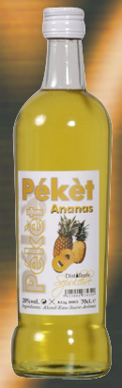
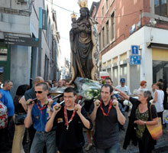
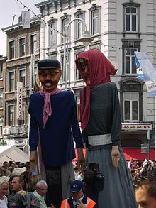

< http://www.dhnet.be/regions/liege/article/277155/pres-de-200000-personnes-a-liege-pour-feter-le-15-aout.html
http://www.belgian-distillery.com/liste-produits.php?cat=p_aro
http://fr.wikipedia.org/wiki/15_ao%C3%BBt_en_Outremeuse

Step 2: Ask questions to the class:
1. What do these pictures mean for you?
2. Do you know who is celebrated on the 15th August?
3. In Liege, a Wallonia city in Belgium, is it only a religious celebration?

Step 3:
For non French class, show this 10’ movie without sound (mute) and ask them to explain in order the major steps of this celebration of 15th August.
http://www.youtube.com/watch?v=g26K3PxVe9E
After this step, you can make the class read and check the right step with the short explanation text attached.

For French class, show this 10’ movie and ask them to explain in order the major steps of this celebration of 15th August.
http://www.youtube.com/watch?v=g26K3PxVe9E
After this step, you can make the class read and check the right step with the short explanation text attached.

Step 4: Ask the students about this celebration of Assumption in their own countries

Material request

1. Three pictures on paper or data
2. A data to show them the You tube link
3. The short text attached in French or English

Annexe

L’agenda du routard

Fête du Peket (Fêtes du 15 août) à Liège
Ces fêtes qui se déroulent en Outremeuse comptent parmi les plus vivantes de Liège ! Elles s’étalent en fait sur plusieurs jours et attirent plus de 200 000 personnes.
Le 14, on promène le « bouquet », une structure métallique de 6 m de haut garnie de fleurs et reproduisant les emblèmes des vieux métiers. Suivent des chants et danses folkloriques wallonnes, puis des bals populaires (jusqu’à 2h du mat) dans les rues En Roture et Grande-Bêche.
Au même moment, le tir de campes (une grosse pétarade) marque l’ouverture officielle des festivités (qui en réalité débutent dès le 12).
Le lendemain, le 15 donc, constitue l’apothéose de la fête, avec d’abord une procession de la Vierge noire d’Outremeuse. Départ de l’église Saint-Nicolas (rue Fosse-aux-Raines). Une grand-messe est donnée, en plein air avec sermon en wallon.
La programmation fait aussi le plein d'animations folkloriques : spectacles des marionnettes liégeoises, jeux populaires, mât de cocagne, des spectacles des marionnettes liégeoises au musée Tchantchès. Cortège folklo avec des géants à travers les rues du quartier. Dans la soirée, re-grands bals, notamment rue Grande-Bêche.
Le 16 août enfin, vers 17, c'est l'enterrement de Mâti l’Ohé : un événement burlesque, avec fanfares et vierges éplorées.
<http://www.routard.com/guide_agenda_detail/4095/fete_du_peket_%28fetes_du_15_aout%29_a_liege.htm

Appendix

The Pekêt Celebrations (Celebrations of August 15th) in Liege
These celebrations, which take place in the Outremeuse district, are amongst the liveliest and the most vibrant of the Liege region ! They last for several days and draw more than 200,000 people. On August 14th, the “bouquet”, a 6-meter-high metal structure garnished with flowers and representing emblems of old trades, is taken around the city. Later, Walloon folk songs and dances, followed by popular balls (until 2 o’clock in the morning), take place in the Roture and Grande-Bêche streets.
At the same time, the « tir de campes » (a massive firecracker) marks the official launching of the celebrations (which actually start on the 12th). The following day, August 15th, is the high point of the celebrations, with the procession of the Outremeuse Black Virgin departing from Saint Nicholas church (Fosse-aux-Raines street). A big open-air mass is held with a sermon in Walloon. The celebrations programming also include a huge part of folk animations: Liege puppet show, popular games, greasy pole, traditional puppet show at the Tchantchès museum, a folk cortege with the parade of the giants in the streets of the district and, in the evening, popular balls again. On August 16th, around 5:00pm, it is the burial of Mâti l’Ohé (Walloon for “Mathieu l’Os” / “Matthew the Bone”): a burlesque event, with brass bands and tearful virgins.
Translated from :
<http://www.routard.com/guide_agenda_detail/4095/fete_du_peket_%28fetes_du_15_aout%29_a_liege.htm

