Traditions in Bavaria all year round

January-February

Hornschlittenrennen (sledge race on a traditional sledge)

A "Hornschlitten" is a traditional sledge which allowed the transportation of hay and wood down into the valley during winter times in earlier days. Today , mostly around carnival time, there are some spots in the Bavarian and Allgaeu Alps where people, sometimes in costumes, race down the hill and over big jumps.

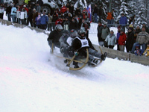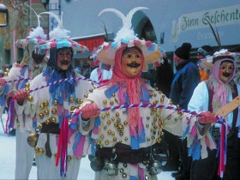

March – April

Starkbierzeit (Strong Beer Season)
Strong lent beer had already been served during this period of carneval since the mid 15th century. Monks brewed lent beer, because they weren't allowed to eat during this period. All these strong beers have the suffix "-ator" in their name, like: "Delicator", "Triumphator", "Animator" and so on. One of the most famous events takes place at the "Nockerberg"
where a barrel of "Salvator" is tapped and the politicians have to face their critics in a very humorous way - which is called "Derblecken"

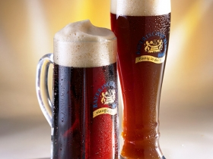
Easter
In true Bavarian style Easter is celebrated with a mixture of ancient traditions and 21st century goodies: “Palmbüscheln” to be blessed on Palm Sunday, Easter Bunny (Osterhase), coloured eggs, kids searching for eggs kindly left by the “Osterhase”, roast lamb lunch, Easter lamb cake and more.

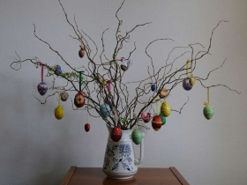

Palmsonntag (Palm Sunday)
First of all, Palm Sunday is a religious feast-day. But beside the religious meaning it always makes people call the one who gets out of bed last this day the "Palmesel" (palm donkey). This is because the donkey is said to be a lazy and easy-going animal. So never get up to late that day (Sunday before Easter), else someone might call you the "Palmesel".
Or simply appeal to the bible: "The latter will be first!"

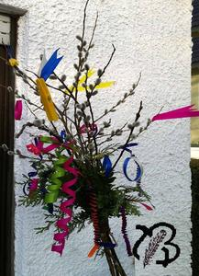

May – June

Maibaum aufstellen (Maypole raising)
Every year there is fierce competition between the towns and cities in Bavaria for where the highest (some up to over 90 feet) and most majestic pole is erected. The Maypole can look different in each region. In some places it is planted with the tree bark, and in others it is stripped and painted blue-and-white, hung with colorful ribbons, decorated with carved figures and adorned with a wreath. The pole is erected by without technical assistance just with thick, long rods (“Schaibeln”) bound together into “Scheren”. This work can stretch out over two hours. In neighbouring communities the young men's associations often try to steal the maypole. According to a custom the stolen pole has to be redeemed by a ransom consisting of beer and food which both communities share together.
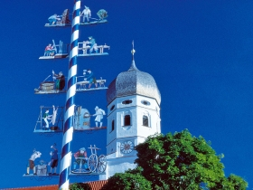

Fronleichnam (Corpus Christi)
Many Processions take place in Bavaria. One of the most interesting ones is the only lake procession near Murnau at Lake Staffelsee where hundreds of people meet with their small boats for a mass celebrated by
the local priest.
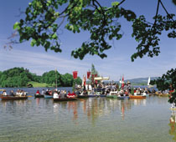

Der Kötztinger Pfingstritt - nur für Mannerleut’ im Sattel
Der fast 600 Jahre alte Kötztinger Pfingstritt gehört zu den ältesten Brauchtumsveranstaltungen in Bayern und beginnt traditionsgemäß am Pfingstmontag um 08.00 Uhr. Die reine Männerwallfahrt, eine „Eucharistische Prozession zu Pferde“, an der sich alljährlich rund 900 Reiter in den überlieferten Trachten und auf prächtig geschmückten Pferden beteiligen, führt zu der sieben Kilometer entfernten Nikolauskirche nach Steinbühl. Der Legende nach hatte ein Geistlicher im Jahre 1412 dorthin einem Sterbenden die Sakramente zu bringen, wobei das Allerheiligste von mutigen Kötztinger Burschen gegen räuberische Übergriffe geschützt wurde.

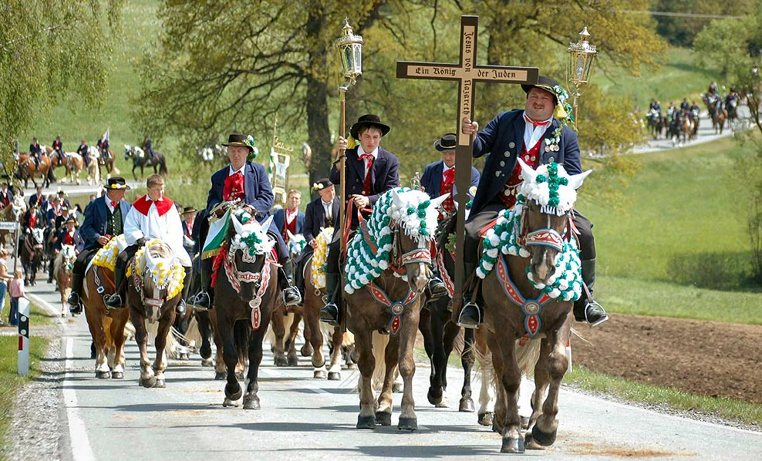

Landshuter Hochzeit
The former capital of Bavaria makes history come alive: Every four years far more than 2000 citizens revive with enthusiasm the whole splendour of the late Middle Ages wearing costumes tailored true to the original. Celebrations take place on four weekends during three weeks: The wedding of the Polish King´s daughter Hedwig to the Duke of Wittelsbach George of Bavaria-Landshut. The next celebration of the "Landshuter Hochzeit 1475" takes place from 28 June - 21 July 2013.

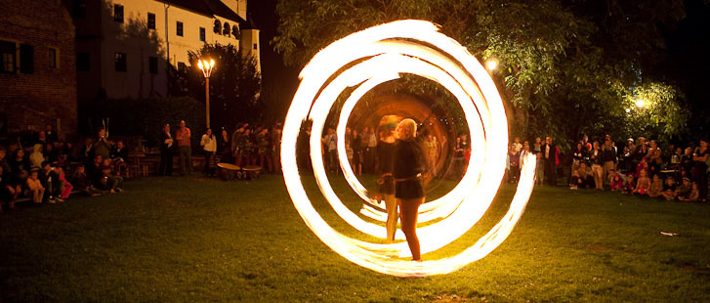

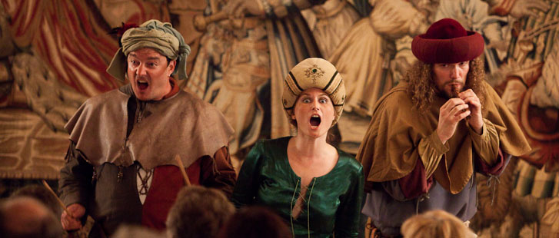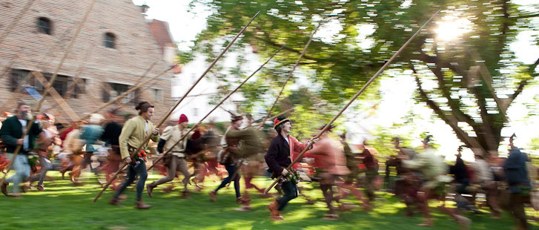

July – August

Ritterspiele in Kaltenberg (Kaltenberg Knights Tournament)
The world's largest Knights Tournament is held in Kaltenberg, not far from Munich, on three weekends in July. 1,200 participants contribute to an incomparable atmosphere at the mediaeval market: juggling and music, the life of knights and historical handicrafts, minstrelsy and magic, food and drink, everything your heart could desire. And in the arena, the world-famous “Cascadeurs Associés” hold a jousting tournament, as breath-taking as any in the 14th century could have been.

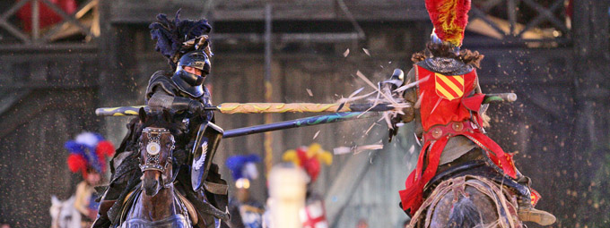

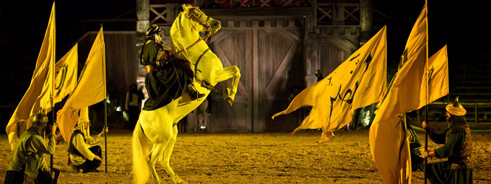

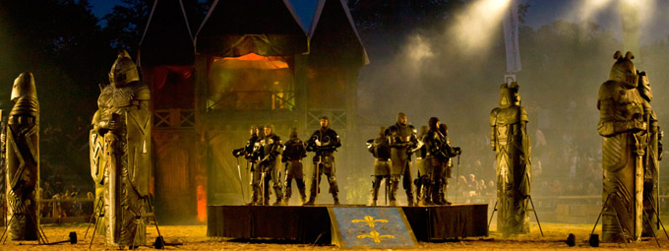

September – October

Viehscheid or Almabtrieb (an autumn cattle-drive from the high alpine pastures)
In early september the cows are driven back downhill. The lead cows (only one per herd) are adorned with ornamental head-dresses and huge clanking bells. By doing so, people celebrate their safe return in towns and villages.

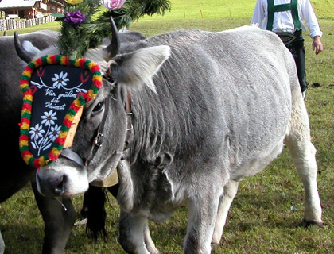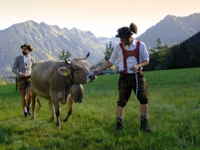

Oktoberfest in Munich

What’s the history behind the Oktoberfest?
It all started with a horse race which the national guard staged for the people on 17th August 1810 to mark the wedding of the Ludwig Crown Prince of Bavaria (later King Ludwig I) to Princess Therese von Sachsen-Hildburghausen. The race was such a success that it was staged again the following year on the Theresienwiese – the meadow named in honour of the Princess. From 1870 onwards the number of stalls began to increase and in 1896 the very first beer tents were erected which sold only beer brewed in Munich – a tradition which has remained to the present day. Due to lack of space the horse races with which it all began were staged for the last time in 1936.
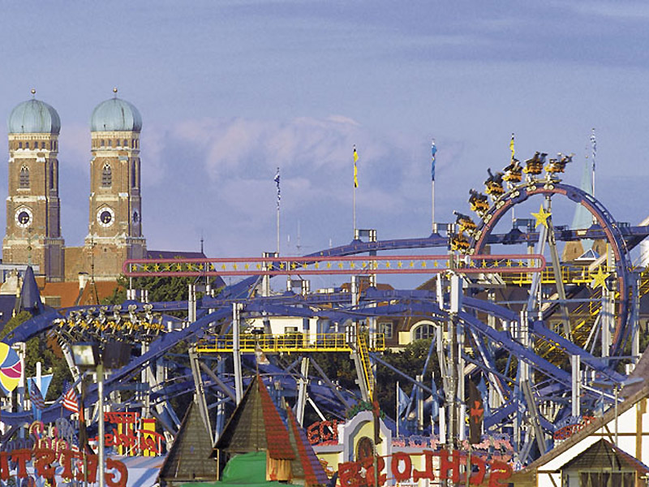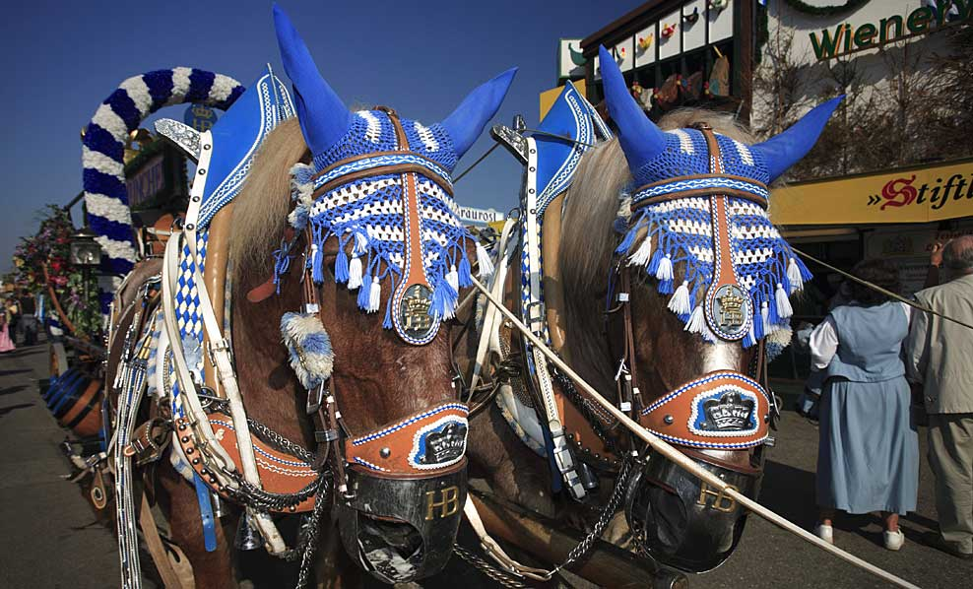
November - December
Leonhardifahrt (St. Leonhard Horse Procession) in Bad Tölz
This major procession honours St. Leonard, and features townsfolk dressed in traditional garments, as well as brass bands and flower-festooned horse carts. Most famous version of this is in Bad Tölz.

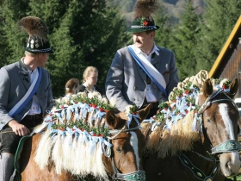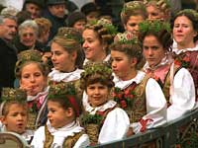

Christkindlmarkt (christmas markets in Bavaria)
Traditional German christmas markets are becoming more and more famous among tourists. Just think about the world famous Nuremberg Christkindlsmarkt, the mulled wine (Glühwein), the gingerbread (Lebkuchen) and all the other typical stuff. Most christmas markets in Bavaria start in the last week of November and last until two or three days before Christmas Eve.

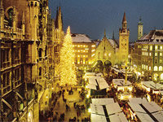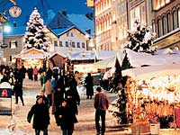

“Sylvester” - the German term for New Year’s Eve
is celebrated with festivities of all sizes from large gala dinners and balls to local festivities in cities, towns and villages across the state. Wherever you choose to see in the New Year sparkling wine and fireworks are bound to feature prominently.
Private parties surrounded by your closest friends often involve eating a fondue or a raclette, singing, dancing and the tradition of “Bleigiessen”. A small piece of lead is melted in a spoon over candle flame and then dropped into ice cold water. From the shape formed by the hardened lead predictions are made about what is going to happen during the year.

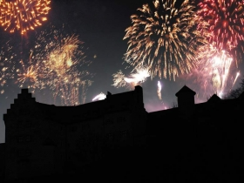

Traditions in the Bavarian Alps
New Year's Eve Shooting in Berchtesgaden: Similar to Christmas Eve, on December 31st, numerous members of the shooting clubs use their black powder guns (Handböller) to salute the New Year. Shooting starts at 23:30 and increases in volume until midnight. Many locals set off fireworks and firecrackers as well. In numerous farms prayers are said, special candles lit and incense burned. This is called the second 'incensing' night.

