**Ten things to know about Liège**

1. **Its geographical location**: in the heart of Europe and of the Meuse-Rhine Euroregion (around the city-corridor of Aachen-Maastricht-Hasselt-Liège). It’s really a multicultural destination, which offers a great diversity of nationalities and religions.
2. You have to learn to **be flexible and indulgent with the weather which can be very capricious** (on the same day you can need both your umbrella and your sunglasses) **as well as with schedules** (for example, we have a small breakfast, a quick snack at midday, and so we normally eat a hot meal quite early in the evening, i.e. before 7.30pm). That’s why shops are closed early, at the latest at 6.30pm.
3. The inhabitants of Liège are **friendly, warm and always in a festive mood**. Attend once a football match of one of the most successful clubs in Belgium, i.e. Standard Liège, and you will see what I mean!

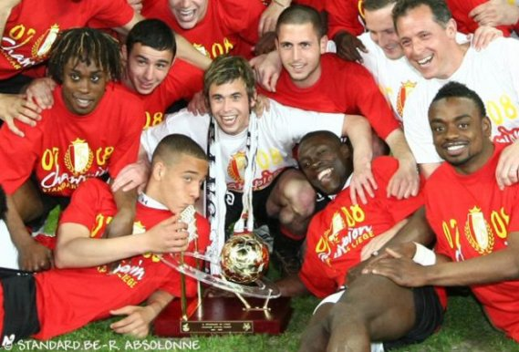

1. The folklore and the traditions in Liège are widely **influenced by the industrial background of the city**, as you can see **in the Outremeuse area** with its famous character **“Tchantchès”** and its local alcohol, the **“péket”**.

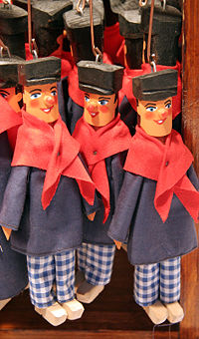 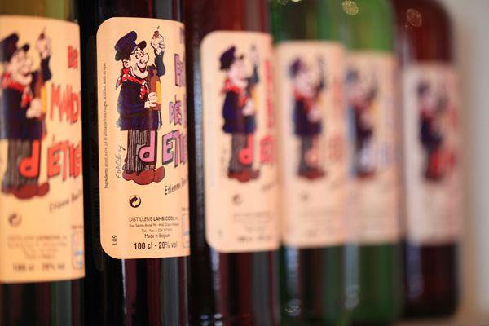 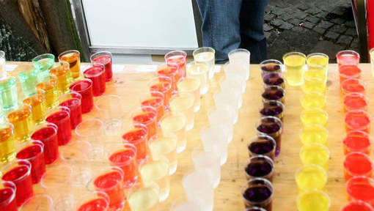

1. **The events you should be at and absolutely not miss are the festivities of “Le Quinze Août”** which celebrates the Virgin Mary, with among other things a procession of the Black Virgin, an open-air mass in Walloon and a cortege with the parade of the giants, etc. **as well as “Les Coteaux de la Citadelle”** which takes place on the first weekend of October.

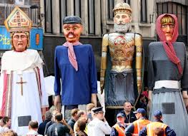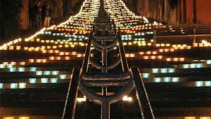

1. **The students’ folklore**: the **Saint Nicholas** festival around the 6 December **organized by and for the students of the University** - for 24 hours, the students (wearing very **dirty lab-coats**) are **allowed to beg for money for drinking**; the **“baptême”** which is specifically Belgian, i.e. a kind of hazing process which includes the practice of some rituals (like songs, etc.) and other activities used as **a way of initiating a person into the student body**; **“le Carré”** in English "the Square" **with many lively pubs** which are reputed to remain open until the last customer leaves; the **“Saint-Toré”** which takes place during the third week of March.

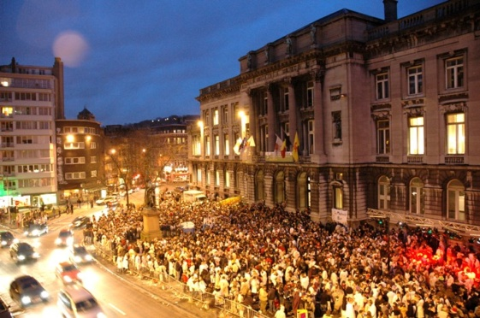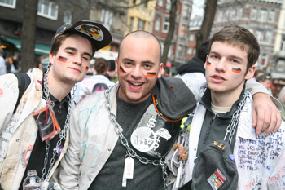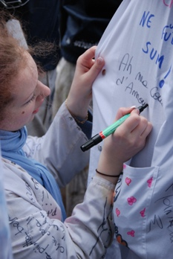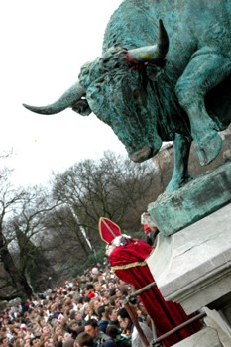

1. **Places to go to in Liège are**:  
   - **the “Batte” Market** - The outdoor market that goes along the Meuse River is one of the biggest in Europe.

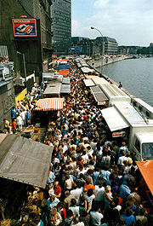

- the **Place Saint-Lambert**, a square in the centre of Liège, with **the former Prince-Bishops' Palace**. Until 1794, it was the site of St. Lambert's Cathedral. **Remains of the foundations of the cathedral** have been conserved, and **are on display at the Archéoforum museum**, under the square.

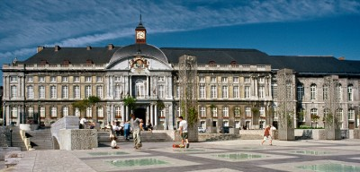

- the **“Place du Marché”** and its **perron** (a stone column, decorated with a globus cruciger, that was erected in cities belonging to the erstwhile Prince-Bishopric of Liège (980-1795))

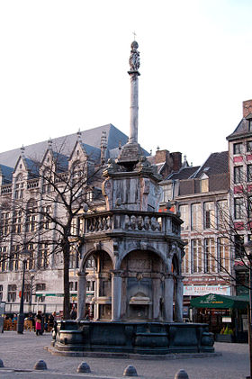

- the **stairway of the Montagne de Bueren**

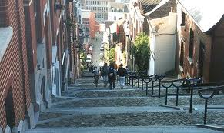

- the **Museum of Walloon Life** and **its puppet theatre**

- the **Royal Opera of Wallonia** and Liège **Royal Philharmonic Orchestra**

- the new **Liège-Guillemins station designed by** the famous architect **Calatrava**

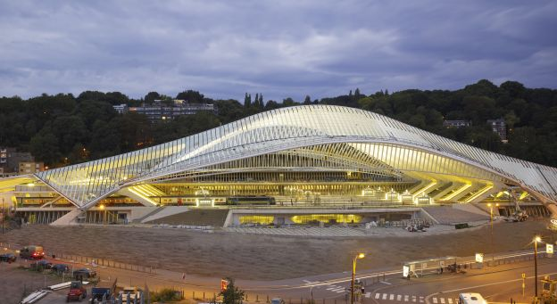

1. Eating and drinking in Liège: **What are the local specialties?**

- the **meatballs “Liège style”** (with apple butter) **and french fries**

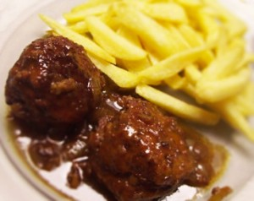

- the **“salade liégeoise”** (beans with potatoes and diced bacon drizzled with vinegar)

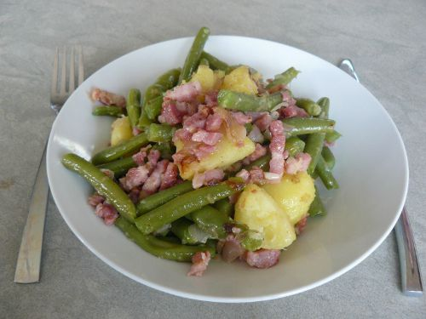

- the **waffels**

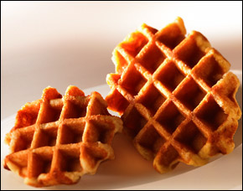

- the **“spéculoos”**

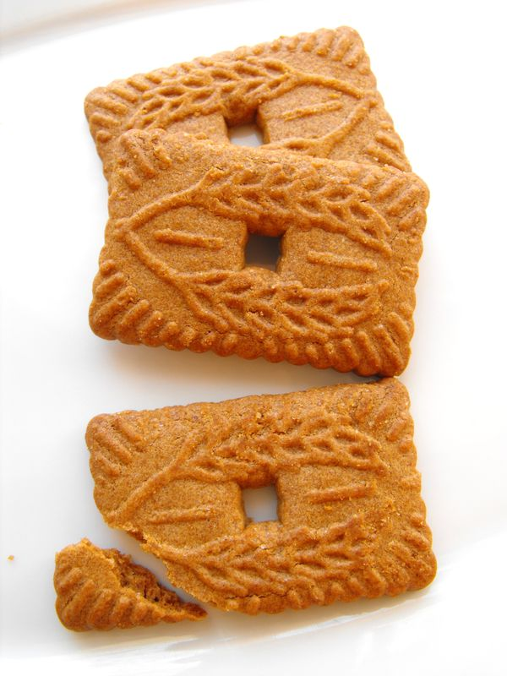

- the **“péket”** of course, and so many other things… !

1. **People who make things happen in Liège**:

- the moviemakers: **the Dardenne brothers**

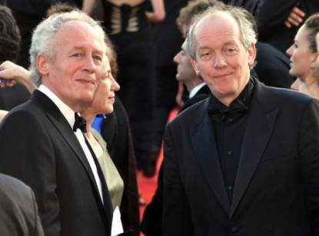

- the draftsmann and cartoonist: **Pierre Kroll**

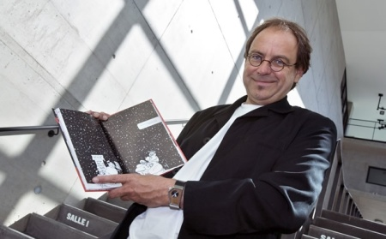

- the writer: **Georges Simenon**

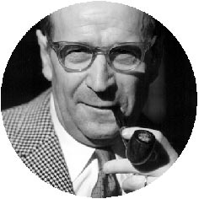

- the sportsman (table tennis): **Jean-Michel Saive**

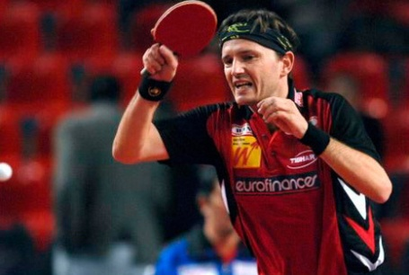

- the actress: **Marie Gillain**

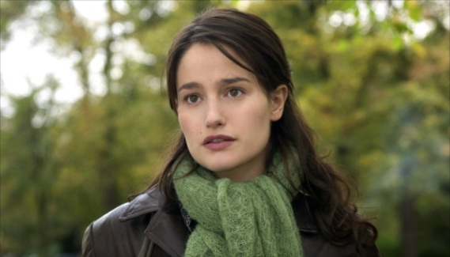

1. **The kiss: something very special!** We kiss each other on the cheek, just once, never mind if it’s the first time we meet or not. And we don’t care if it’s a boy or a girl!

**Sources :**

* Standard Liège : <http://b3.img.v4.skyrock.net/1299/46501299/pics/2080646411_small_3.jpg> (18/10/12)
* Tchantchès : <http://upload.wikimedia.org/wikipedia/commons/8/86/Tchantches.jpg> (18/10/12)
* Péket (1) : <http://www.cave-seresienne.be/Medias/Webshop1/cat_41277_a.jpg> (18/10/12)
* Péket (2) : <http://static1.7sur7.be/static/photo/2012/8/6/8/20120815171207/media_xll_5089823.jpg> (18/10/12)
* Quinze Août : <http://images11.levif.be/images/resized/400/016/111/743/1/500_0_KEEP_RATIO_SHRINK_CENTER_FFFFFF/image/4000161117431.jpg> (19/10/12)
* Les coteaux de la Citadelle : <http://www.michelfirket.be/wp-content/uploads/2012/09/DSC3795-580x330.jpg> (19/10/12)
* Saint Nicholas (1-4) : <http://www.ulg.ac.be/cms/c_36320/photographies-folklore-etudiant> (20/10/12)
* the “Batte” Market: <http://en.wikipedia.org/wiki/File:Li%C3%A8ge_Batte2_JPG.jpg> (20/10/12)
* the Place Saint-Lambert: <http://www.liege.be/tourisme-nl/photographie-de-liege/pl-st-lambert-2.jpg/image_preview> (20/10/12)
* the perron: <http://fr.wikipedia.org/wiki/Fichier:Liege_20080223_Fontaine_Jean_Del_Cour_1.jpg> (20/10/12)
* the stairway of the Montagne de Bueren: <http://faimg1.forum-auto.com/mesimages/194413/buren.jpg> (20/10/12)
* Liège-Guillemins: <http://www.topboxdesign.com/wp-content/uploads/2010/07/Li%C3%A8ge-Guillemins-TGV-Railway-Station-by-Santiago-Calatrava-588x321.jpg> (20/10/12)
* Meatballs: <http://www.vollamac.be/sites/default/files/u3/Boulet-frites.jpg> (21/10/12)
* Salade Liégeoise: <http://p1.storage.canalblog.com/13/50/1006677/78526639_o.jpg> (21/10/12)
* Waffels: <http://www.avieta.be/files/gaufres/prod_sucre.jpg> (21/10/12)
* Spéculoos: <http://p9.storage.canalblog.com/91/96/562899/56814183.jpg> (21/10/12)
* the Dardenne Brothers: <http://en.wikipedia.org/wiki/File:Fr%C3%A8res_Dardenne_Cannes.jpg> (21/10/12)
* Pierre Kroll: <http://www.cinetelerevue.be/imf/c/eyJtYXNrIjoiNjE4eDM5NyIsIm0iOjF9/images/actus_interviews/pierre-kroll-09-reporters.jpg> (21/10/12)
* Georges Simenon: <http://www.devoir-de-philosophie.com/images_dissertations/139006.jpg> (21/10/12)
* Jean-Michel Saive: <http://static0.7sur7.be/static/FOTO/pe/15/1/3/large_354213.jpg> (21/10/12)
* Marie Gillain : <http://image.toutlecine.com/photos/e/n/f/enfer-2005-05-g.jpg> (21/10/12)