Legends

The Legend of Tchantchès
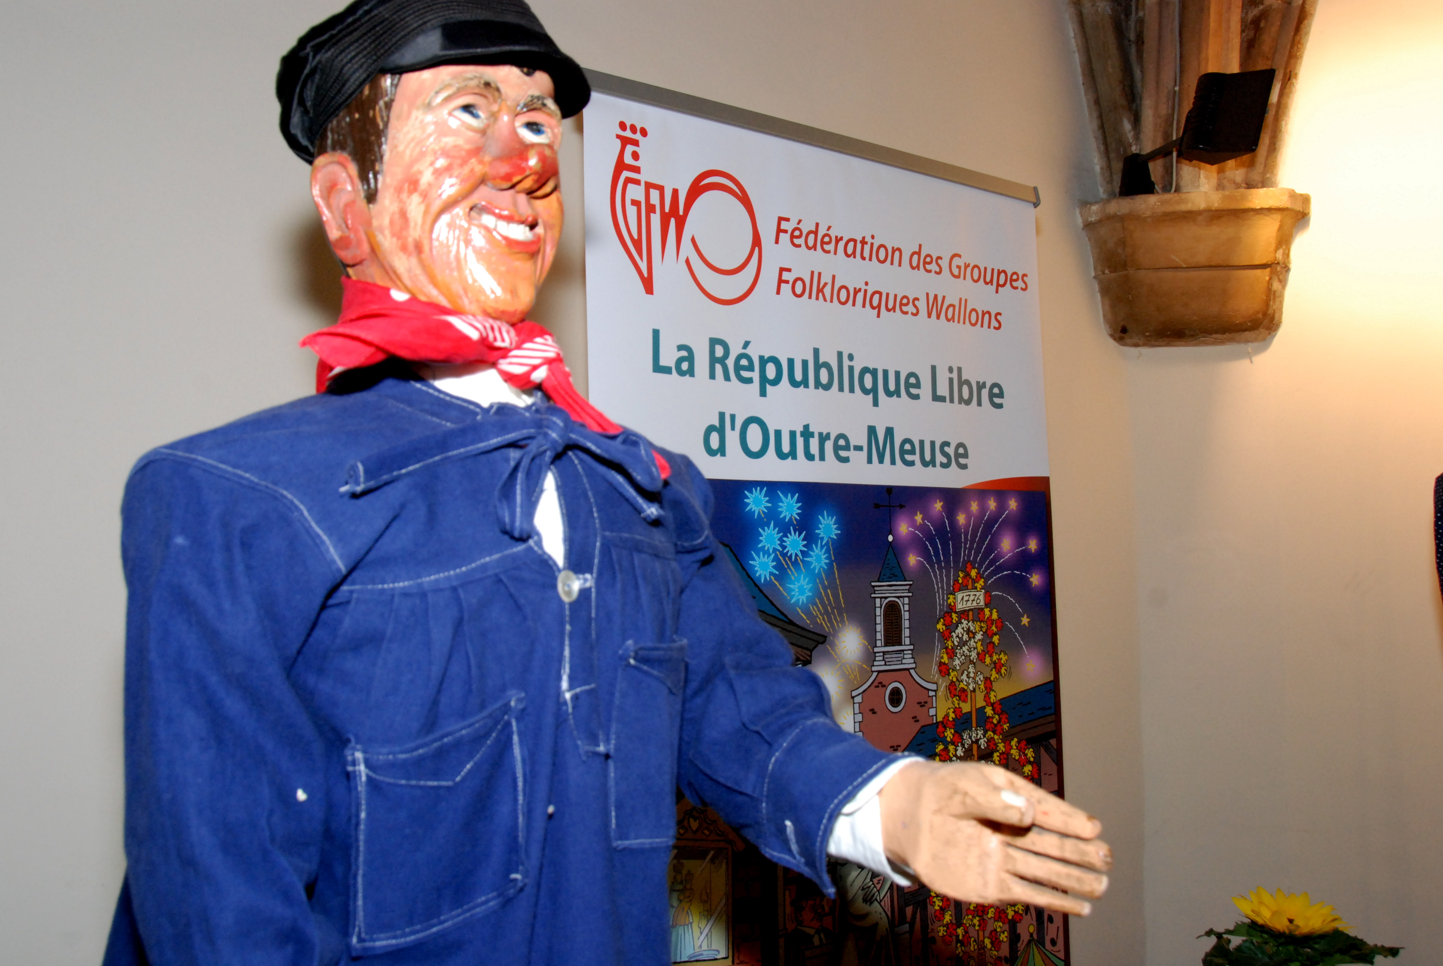
Tchantchès, according to a local tradition adorned with some naive anachronisms, was born in Liège miraculously on August 25th in 760 : he came into the world between two cobblestones of the quarter of Outre-Meuse, today’s Free Republic of Outre Meuse. The kind people who found him were wonderfully astonished to hear him sing as soon as he came into being: "Allons, la mère Gaspard, encore un verre!" (“Come on, Mother Gaspard, one more drink!”).

He was a chubby and greedy baby laughing ceaselessly; nonetheless, he sulked at the sight of a glass of water; in order to make him nice, his adoptive father made him suck a biscuit soaked in pékèt; he weaned him with a kipper and his orphan contracted, for the rest of his life, a unquenchable thirst. Like those who are destined for a great future, Tchantchès experienced the streak of bad luck in his life: during his christening, the midwife inopportunely hit his nose so that the poor child’s proboscis began to grow beyond measure and the face of the innocent victim turned ridiculous to the extent of being an example for carnival masks.

Later, suffering from measles, the toddler had to drink ferruginous water: as a continual unfortunate, he swallowed a horseshoe that remained stuck in his throat. Therefore, he was not able to turn his head from left to right and from right to left anymore, he had to lie flat on his stomach in order to stare at the ground and to lie on his back to look at the sky.

Because of his Cyrano nose, Tchantchès, first, hesitated to go out, but soon, his instinct of freedom made him face the crowd and he allowed himself to take part in Saint-Måcrawe, that is to say, being carried while being daubed with black soot on a litter carried and escorted by all the people of the neighbourhood.

This memorable event happened the day before the Assumption in 770. He experienced great triumph and soon realised that ugliness, going hand in hand with a wit mind and a good soul, could be loved.

One day, as he was wandering by the water (La Meuse), he met the bishop of Turpin and Roland, Charlemagne’s nephew. Turpin reprimanded Roland on his deplorable grades in Latin. Tchantchès, with his usual insolence, took part in the conversation and, in order to reach an agreement between the master and his pupil, pronounced this thoughtful saying:
“Yes, Sire Knight Roland, Latin is good for nothing, but is still really useful”. “Who is this yokel?” asks Roland. “Tchantchès, Prince of Dju d’là, at your service Sire”. The bishop Turpin looked at our friend with indulgence: “Well, Tchantchès, I am going to introduce you to Lord Charlemagne, from now on, you will serve as a companion for his nephew Roland”. Thus, Tchantchès was introduced to Charlemagne’s court. Then came the brilliant expedition to Spain. History is filled with very interesting anecdotes, showing the intimacy that Tchantchès shared with Charlemagne. Then, one day, he deliberately came in the Emperor’s tent. The later was having a formal gala dinner and told him while swallowing his food: “What do you want Tchantchès? Leave me alone eating my mussels”. Another time, he worked as a chamberlain for the august combatant: “Sire Emperor, the diplomatic service of the black Negro, King of Marsille, wants to talk to you”. “How many are they?” “There is only one person”. “So, let them come in by two and the latest will close the door”. Tchantchès did not leave Charlemagne and Roland nor during the night neither during the day: under all circumstances, during private councils or on battlegrounds, he was always there to help them with his judicious piece of advice or his impressive head-butts, because Tchantchès was the champion of the “soukeus de Dju d’la”. Here is Tchantchès’s way to fight: without any lances, any spears, any swords, as a Gonfalone a red kerchief, as a shield, a blue smock as a helmet, his cap made of black silk set up in no time at all on his head as strong as a rock. He spits in his hands, grabs the enemy by the two shoulders, and bam! Right in his breastbone, give him a head-but that breaks his ribbing and takes him in a better world. No cuirass, how strong it may be, can resist to the masterful ram; every man affected by Tchantchès is a dead man, and himself, thanks to his blessed nose, is unassailable.

During the battle of Roncevaux, Roland too audacious, sent Tchantchès to bed: he was yawning during the fight and, as for him, he had smashed the ribbing of at least three thousand Saracens. It was the only reason of the disaster. How deep was the grief of the Liégeois hero and Charlemagne when they looked at the unmoving body of the valiant Roland! In order to show his sadness and according to custom, he took off his cap and tore off his hair while pronouncing this funeral homily: “Sire Emperor, your valiant nephew, we will avenge him!”. Tchantchès went with his master to the siege in Saragosse and it was him who crossed the first ramparts of the city. Back to Aix-la-Chapelle with the imperial court, he attended the punishment of the traitor Ganelon. This felon had to be quartered, but Tchantchès stood against it. He wanted and got the disloyal count to be drown in a cistern of distilled water, torture that our man believed the only one logical, as it happens, because usually in Liège, he heard people sing: “Lâche, va-t-en, je te renie. A toi l'opprobre et le mépris!” (“Coward, go away, I disown you. All that you have for you is opprobrium and contempt!”) What he understood was : all that you have for you is proper water and contempt

Tchantchès, despite the Emperor’s entreaties, came back to his beloved city of Liège and never took comfort of having slept during the last phase of the battle of Ronceveaux. After having had a feast, he died from Spanish flu and was buried where his monument can be found: place de l’Yser. Nothing could knock him down, not even love, because he remained single, not even old age, he passed away when he was 40 years old! Missed by all the population, he remained the model of the true Liégeois: bad look, rebellious mind, enemy of ostentation and huge ceremonies, fiercely independent, but with a heart of gold prompt to be filled with enthusiasm for noble cause.

Jean Bosly
Tchantchès : Children word for the first name Françwès in wallon dialect (François).He’s the one who fights with his head, hitting with it.

Source : http://www.tchantches.eu/index.php/legende-de-tchantches, consulté le 9/1/2013. Avec l’aimable autorisation du Musée Tchantchès

