Susan and the king of drowners

A long time ago in the town Vistula lying on the river Vistula, there lived a bad host Kurzejka, a good girl, and “drowners”. “Drowners” are the water creatures, maybe water-elfs, maybe kelpie suicide’s souls, and perhaps rebellious angels knocked to the ground. In the area there lived also a king of the drowners.

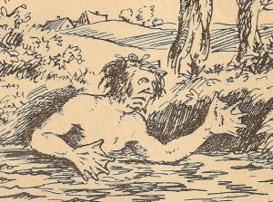
/from: www.wykop.pl/

The girl's name was Susan and she was an orphan. She had to work for a bad host Kurzejka. She did almost everything, and got almost nothing for that. Almost nothing, because the host usually yelled at her and sometimes beat her. The drowners saw everything and talked about it to their king. Finally he decided to do something. First he wanted to see for his own eyes, how she is doing. He turned into a toad and was peeking through the window, what's going on in the Kurzejka’s hut. As usual, Susan was in a bad situation.
Morning came and the king of drowners could not go back to the river by his own, because it was too dry. He had to wait in the shade and hope for someone's help. Soon Susanna came out of the hut. The king asked her to carry him to the river, however, did not reveal who he was. She selflessly helped to the poor toad. When the king was gently put into the water, he took its own character. On his head there was a crown. He asked the girl what she wants for saving his life. He offered her treasures, drowning the bad host or his family, or even more treasures. But the girl did not want anything like that. She asked the king, who is the lord of the river, that he made it never flooding anymore. The king agreed, and told the girl to go home.
In the evening, Susan, as usual, went to sleep on his mattress in a barn. In the morning she got up sore. The straw, which was stuffed with the mattress, turned into gold. The bad host saw that and demanded an explanation. The girl told him everything. Kurzejka started to draw gold pieces of straw. However, these as soon as they were touched by him, turned into a simple straw again. He thought a moment and said that this time he is going to find toad with a crown in the morning. He is going to help her and then ask for an appropriate reward. King of drowners heard everything. The next day he was waiting for the host in the form of a toad with a crown on his head almost on the threshold of his hut. The host threw a toad into a bag, and then never touching it with his hands thrown into the river. Then he said: “I saved your life. I deserve a reward.” King emerged from the water and asked:
- What do you want?
- I want you to reward me as Susanna.
- Good.
The host went into the house. He put a mattress on the box with golden ducats and fell asleep. When I woke up in the morning, stated that there is a simple straw in the mattress, and in addition gold ducats turned to straw. Drowners not always keep their word.
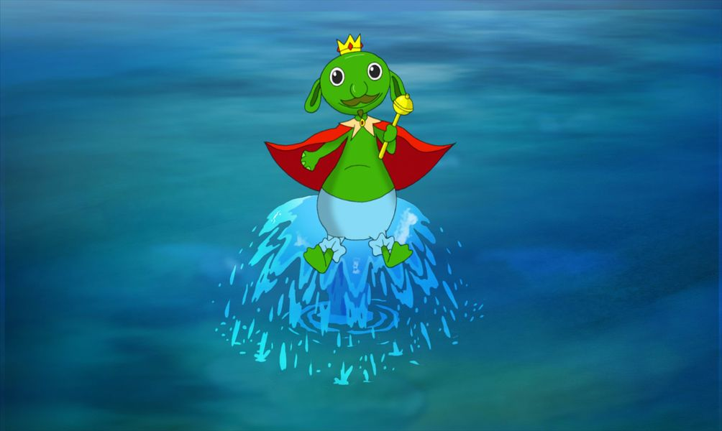
/from: www.tvsfa.com/

Since then Vistula have not shed anymore and there was no flooding.
And Susan ... but that's another story.

