“Special Tradition 1”- Erecting a May Pole
Informal Activity in the Classroom to Approach Culture
(Cultural activity)

Suggested exercises
Step 1:
- Give learners one drawing each (or 2 to build smaller groups) of a sequence of drawings about a special tradition in a region or a country.
- Tell them how many drawings are necessary to get the whole description of the event.
- Learners build groups so that each group has got all drawings.
- Learners put the drawings in the right order of the happenings and stick them on a large sheet.
- Each group prepares a description of the event (speaking or writing).
- Each group choses one speaker.
- The speaker reports about the group description of the event.

Step 2:

Ask the students/learners
- if they know such event or similar ones
- if they know in which countries such events take place
- when and why that event takes place
- to look in Internet for more information about that event
- to prepare a report about the results of their Internet search.

Below: Example of a sequence of drawings related to a “Special Event” in South Germany (Bavaria): Put up a May Pole for the 1st of May.

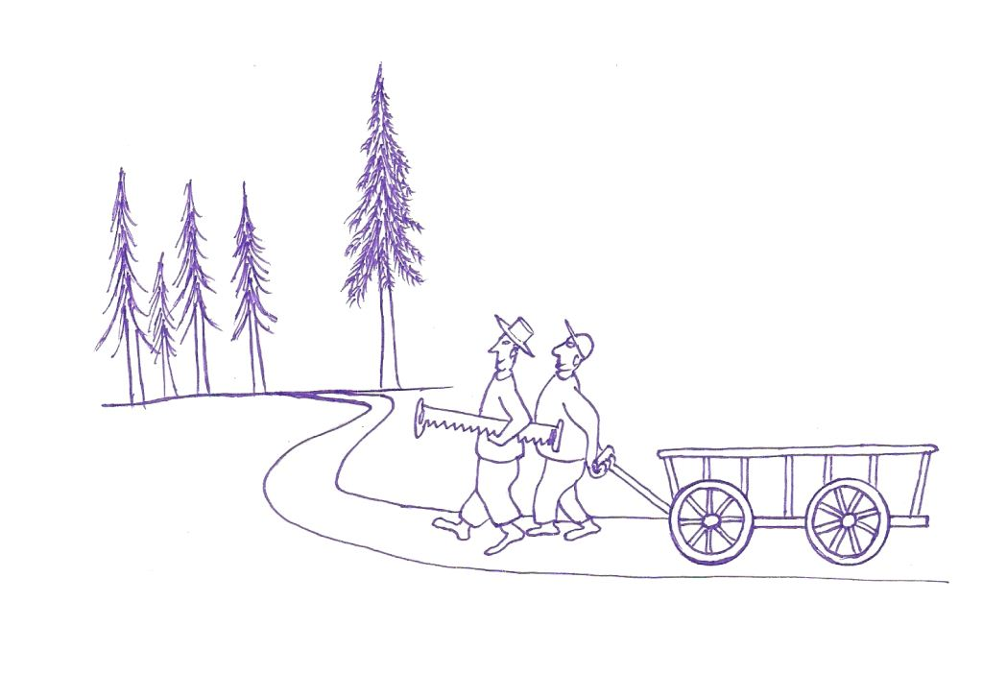 | 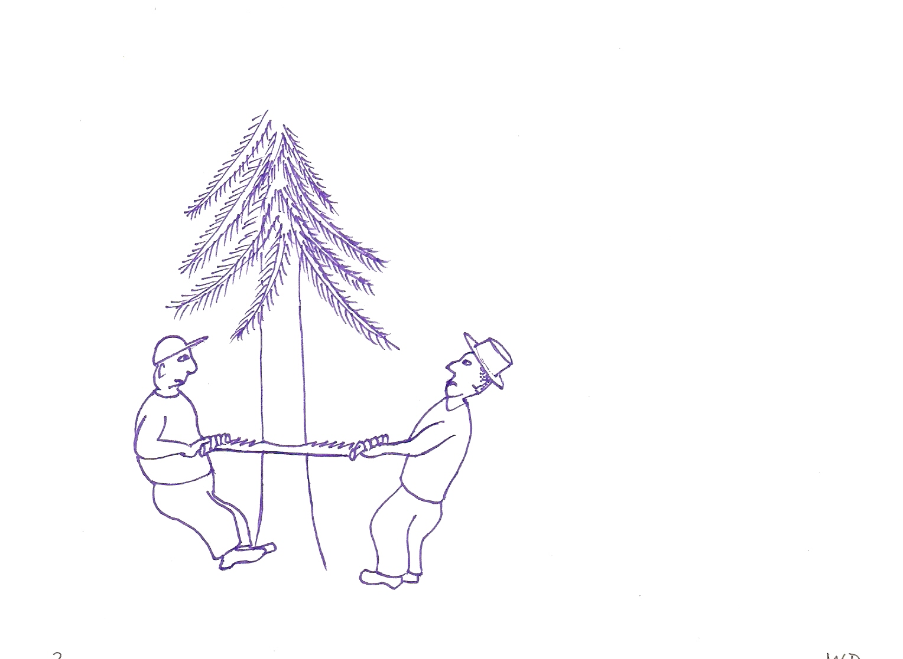
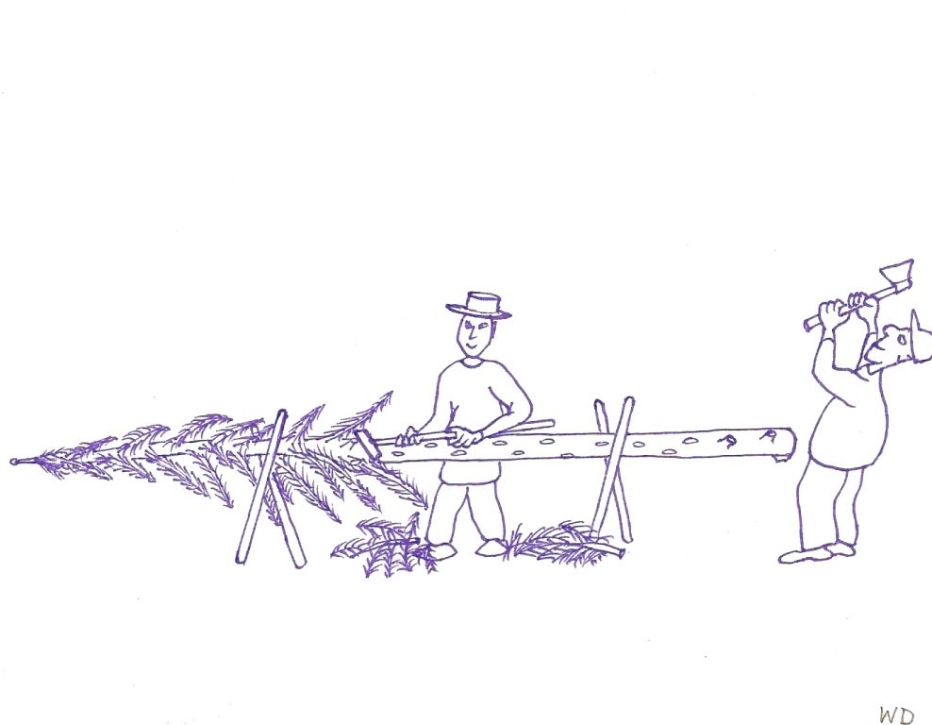 | 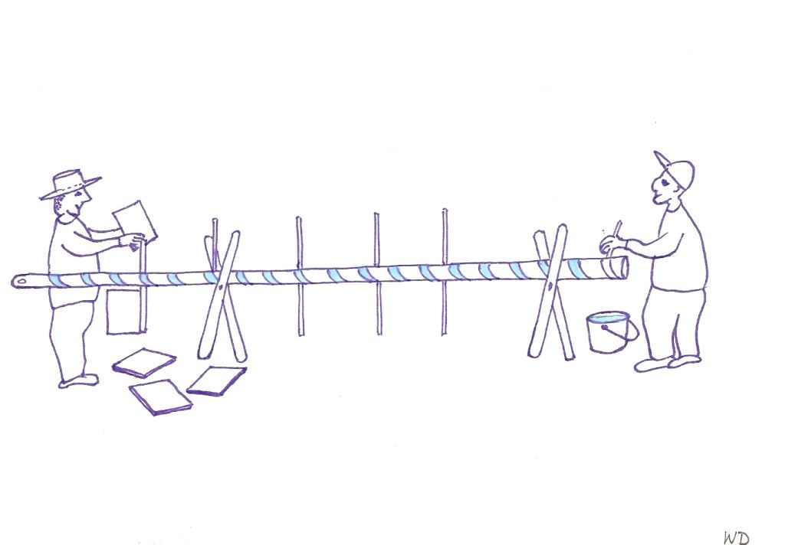
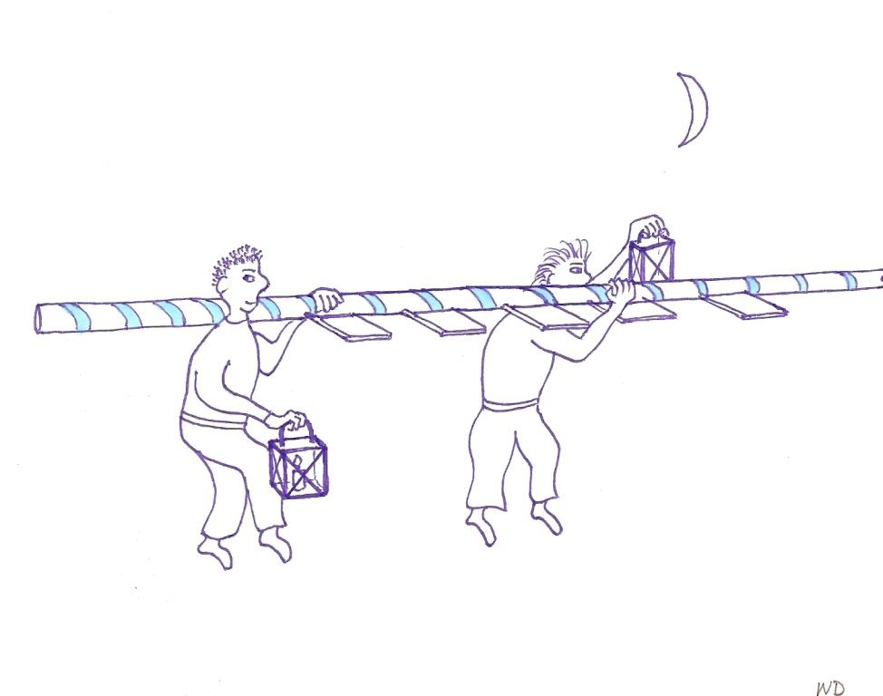 | 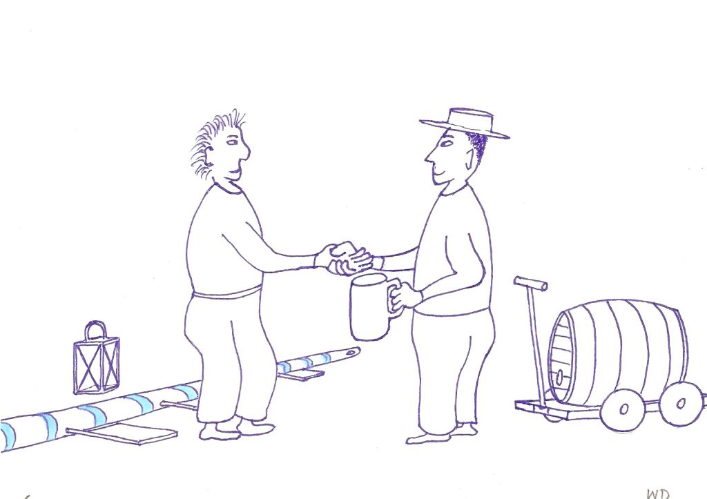
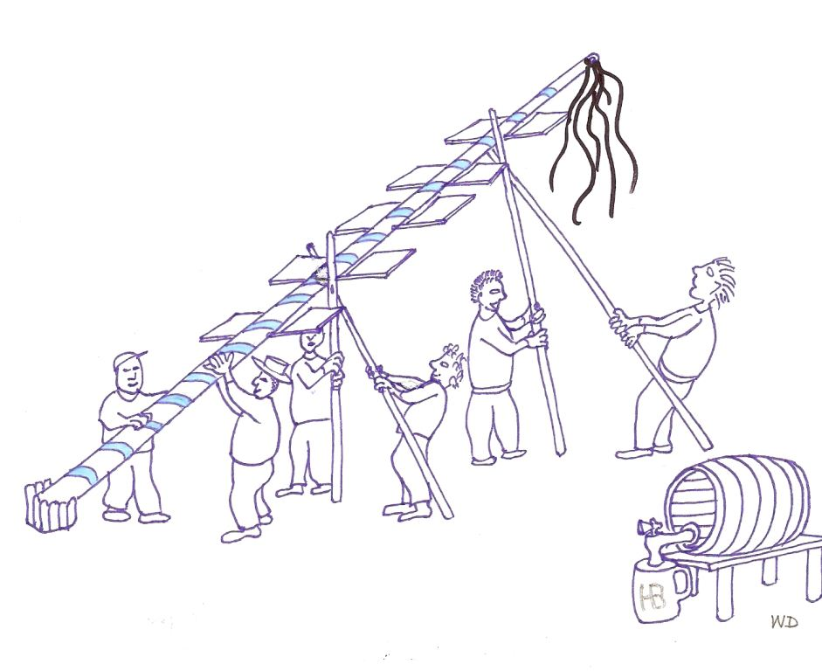 | 