Legends

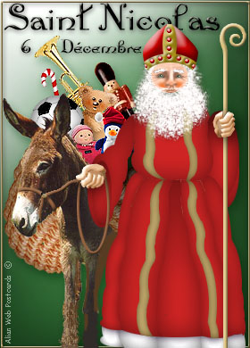
The legend of Santa Klaus

From November, all Belgian children are waiting for Saint Nicholas who will come by December 6th. In Belgium, it is not during Christmas that children are given presents, but during the Saint Nicholas. While waiting for December 6th, from mid-November, children put their slippers in front of the fireplace and, in the morning, they find a fruit or a sweet that Saint Nicholas dropped off during the night.
Saint Nicholas, before December 6th, also comes to schools or stops by some supermarkets along with the Père Fouettard (The Whipping Father), a black person supplied with a stick to beat the children who are not kind. He generally keeps on a leash the donkey loaded with a sack full of toys.
The legend told in Wallonia and in Lorraine (France) teaches us that three young children who were gone picking ears of corn in fields lost their way. After having walked a long time, they asked for hospitality to a butcher. This one invited them to come in, but killed them, cut them to pieces and put them in his salting tub. Seven years later, as Saint Nicholas stopped by, he asked for having supper to the butcher. The latter offered him some ham or some veal, but Saint Nicholas wanted what was in the salting tub… the butcher understood that he was aware of the horrible deed he had perpetrated and ran away. The Old Saint resurrected to three children.
Nicholas of Myre (today’s Turkey) did exist and was a bishop in the same city. He died on December 6th in 345. Sixty-two Italian sailors brought back, on May 9th in 1087, his bones (that, it would appear, seeped out sacred oil) to a Christian land in Bari (Italia)
Pour écouter la chanson que les enfants francophones de Belgique chantent en l’honneur de Saint-Nicolas : http://www.youtube.com/watch?v=R17hFq-VpZc
Pour visualiser une arrivée de Saint Nicolas en Belgique : http://www.youtube.com/watch?v=V_G4H4vhOOk

