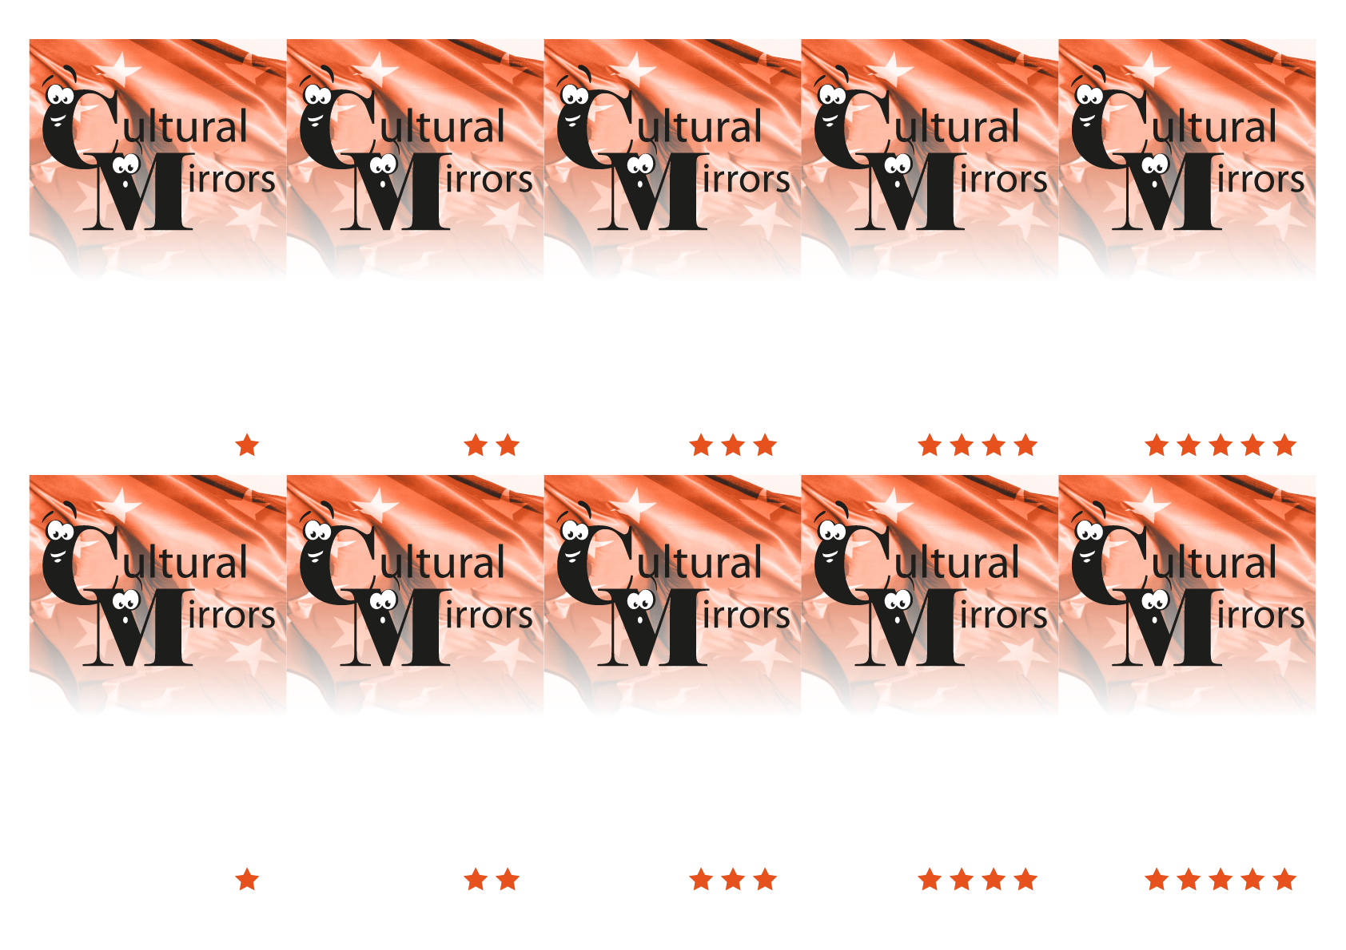
4. It includes the widest Gothic nave in the world, with a width of 22 metres (72 ft), and the second widest overall after that of St. Peter's Basilica (Vatican).
4. To ask that Catalonia became a new state of Europe.

4. Is one of the traditional foods of Catalonia. A slice of bread with tomato
4. We say “bon dia” (good morning), hola (hello), fins aviat (see you), adéu (good bye).
4. Salvador Dalí (1904-1989)
3. Girona has one of the most important Jewish quarters in Europe and had a famous school of Kabbalah in XIIIth century.

3. Catalan and Spanish

3. “Senyera” is the flag of Catalonia.
And “els segadors” is the national anthem.
3. Catalan people eat 12 grapes.
3. A castell is a human tower built traditionally in festivals at many locations within Catalonia (in 2010 castells were declared by UNESCO Masterpieces of the Oral and Intangible Heritage of Humanity).

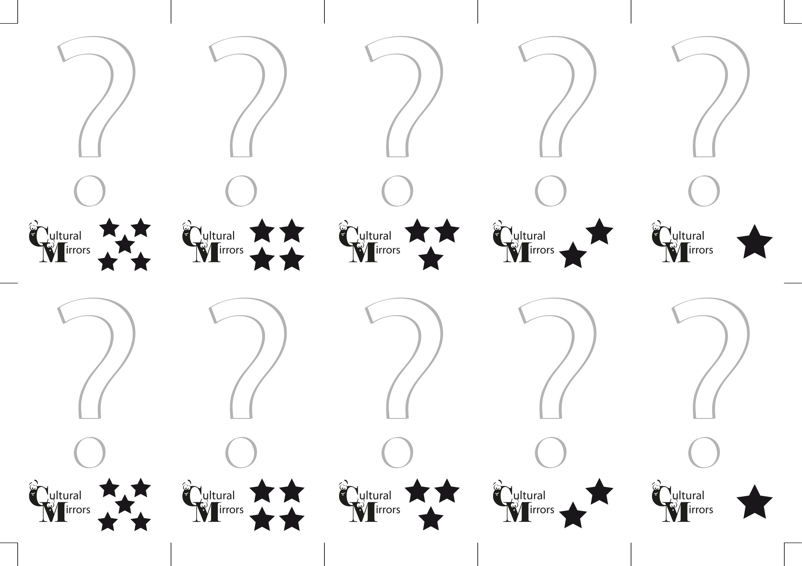
3. What are « castells » ?

3. What special fruit do Catalans eat at midnight on 31st December?

3 What does “senyera” mean and “els segadors” for Catalan people?
3. What are the official languages in Catalonia?
3. Which is the relationship between Girona and the Jewish culture?

4. Do you know the name of one of the most important surrealists artists that has his museum in Figueres?

4. How do we greet each other in Catalonia?

4. What is “pa amb tomàquet” ?

4. Why did 1.5 million Catalans take the streets on 11 September 2012?

4. What amazing feature does the central gotic nave of the Girona’s Cathedral have ?

