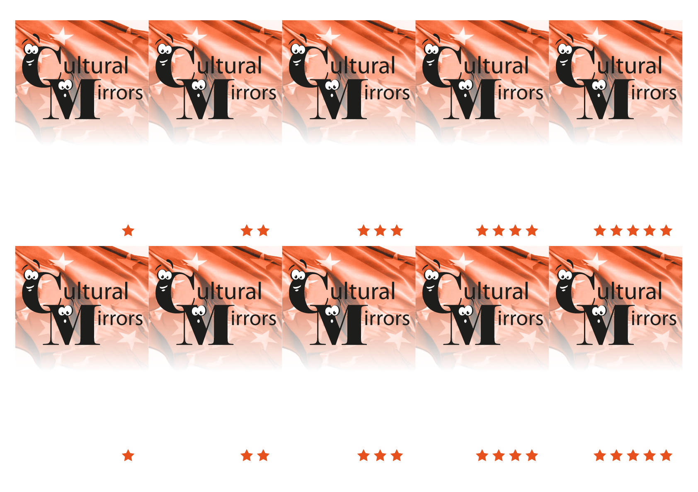
4. Around 200 000
4. Wisła
4. Lady with an Ermine
4. Warszawa

4. Yes, it does.

3. Kazimierz

3. Warszawa

3. Eg. Wawel Castel and the Cathedral, Basilica of St. Mary, Church of St. Peter and Paul, Jagiellonian University, Florianska Gate, Barbakan.

3. That they are stingy.
3. Eg. Maria Skłodowska-Curie, Fryderyk Chopin, Karol Wojtyła, Adam Mickiewicz, Lech Wałęsa, Mikołaj Kopernik


3. Could you name three famous Poles?

3. What is the stereotype of the citizens of Krakow?

3. Do you know at least three historical sites of Krakow?
3. What is the name of the capital of Poland?
3. What is the name of the Jewish quarter in Krakow?

4. Which city does Krakow compete with?

4. Which famous painting of Leonardo da Vinci can you find in Krakow?

4. Which river is considered as a “main” river of Poland?
4. How many students are in Krakow?

4. Does Krakow have its “own” dragon?

