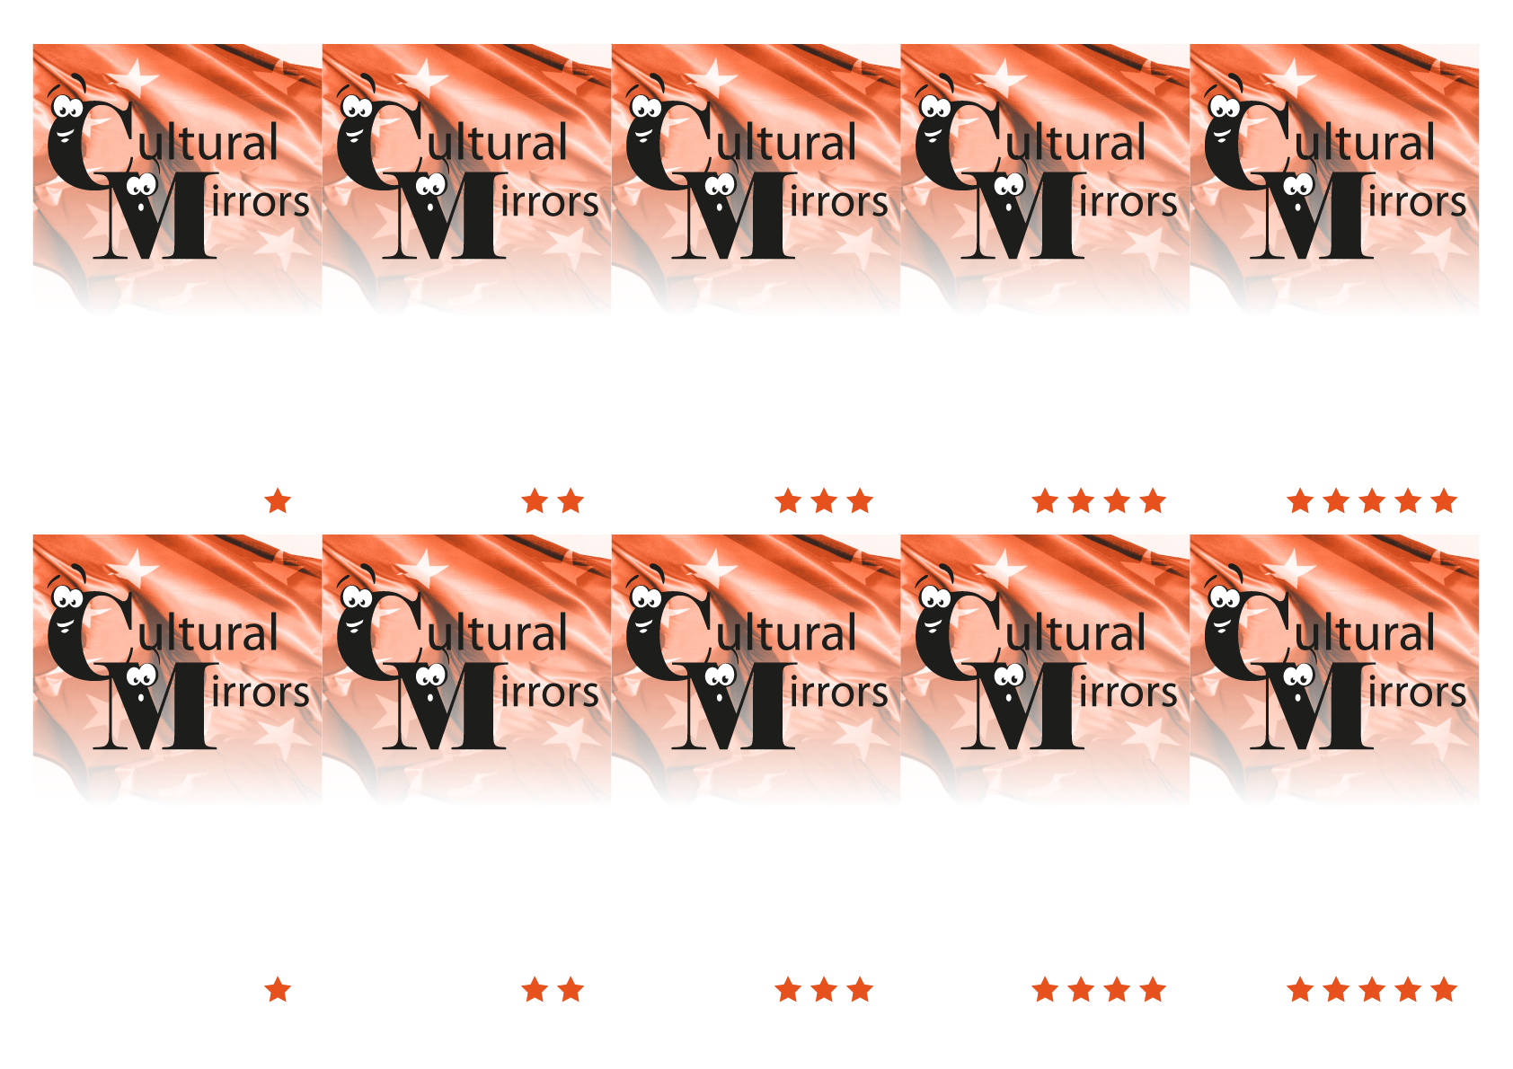
2. Jagiellonian University

2. Football

2. Eg. Juliusz Słowacki Theatre, National Stary (Old) Theatre, Bagatela Theatre, Groteska Theatre of Puppetry
2. It is a type of bread roll topped with salt, sesame or poppy seed, compared to bagel or German pretzel.
2. This is a birthplace of Pope John Paul II.

1. In the south of Poland.

1. Republic
1. Yes, there are.
1. At the monument of Adam Mickiewicz – one of the greatests polish poets.

1. Casimir the Restorer
(Kazimierz Odnowiciel)

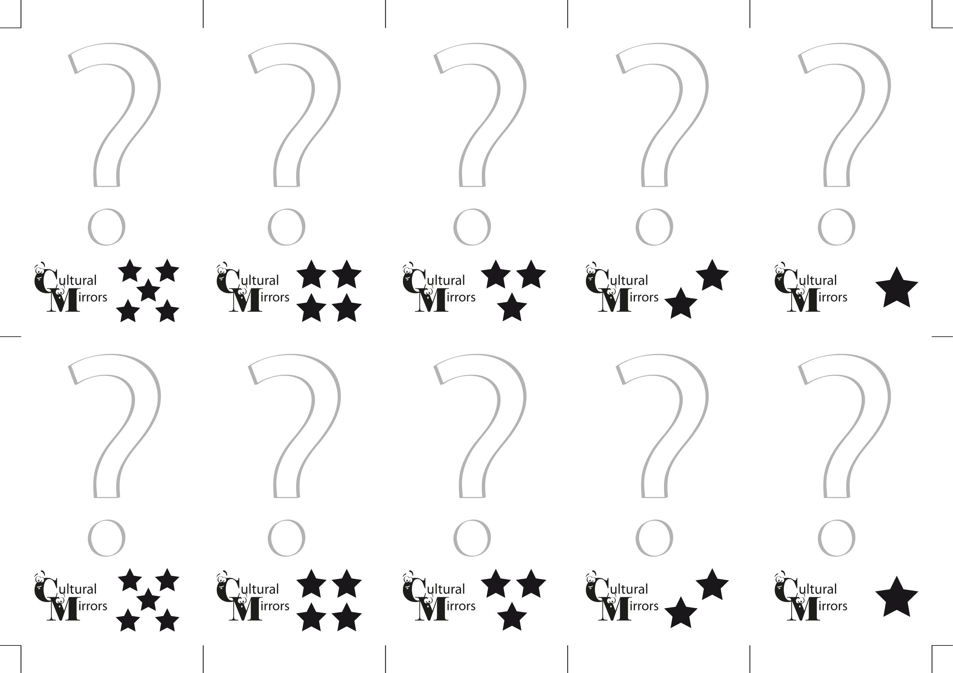
1. Which king moved Polish capital from Gniezno to Krakow?

1. Where is one of the most popular meeting place in the centre of Krakow?

1. Is there an opera and philharmonic in Krakow?
1. Is Poland republic or monarchy?

1. Where is the city of Krakow and the town of Wadowice: in the north or in the south of Poland?

2. What is Wadowice known for?
2. What is Obwarzanek krakowski?

2. Could you name at least three of theatres in Krakow?
2. Which is the most popular sport in Poland?

2. What is the name of the oldest and most famous university in Poland?

