Luxembourgish delicacies

Bouneschlupp : Soup with beans
.
Judd mat Gardebounen : Pork neck with white beans

Friture.: Fried fish

Kniddelen : flour dumplings

Träipen : fried black sausage

Kuddelfleck : precooked fried tripes

Weld: seasonally hunted animals

Kachkéi s: soft melted cheese

Quetschentaart : prune tart

Béier : beer (Luxembourg has many breweries

Quetsch : Prune liqueur

Pinot gris , Pinot noir, Gewürztraminer, Rivaner , Elbling , Rosé ( Luxembourg offers a great variety of wines)

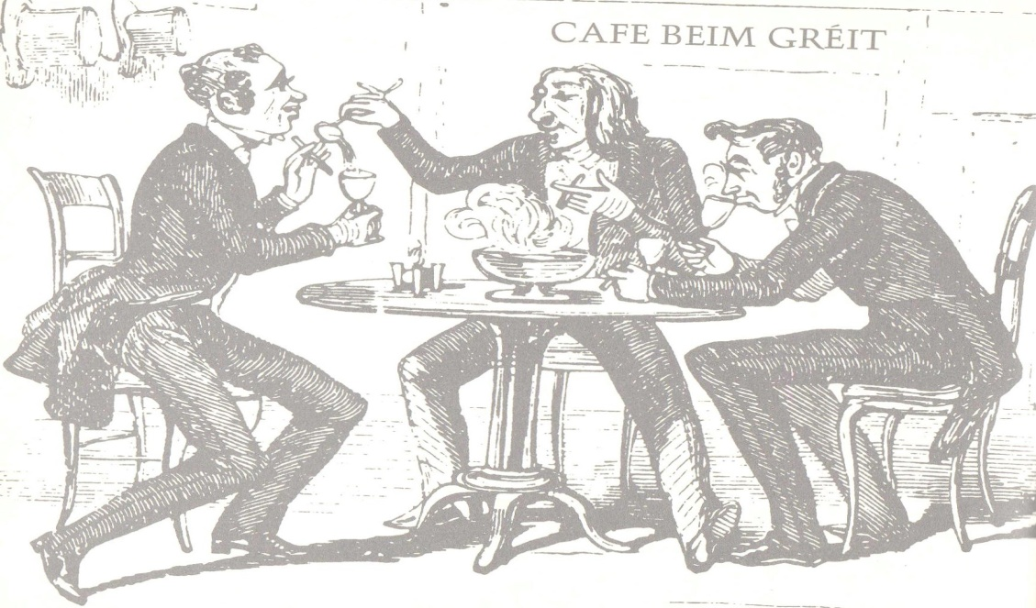
(drawing :Le livre de la cuisine luxembourgeoise : Verlag Hölker ISBN :3-88117-069-3)

