
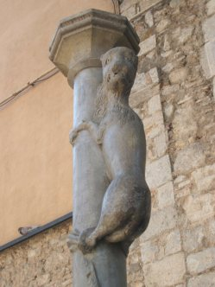
LEGENDS OF GIRONA:
THE LIONESS’ BOTTOM

In the Carrer Calderers (Calderers Street), previously known as Carrer dels Perolers, at Number 19, there was a Romanesque column with a lion climbing it up.
Possibly, this sculpture was used to give the Hostal de la Lleona its name. This hostel was open during the Middle Ages and continued right up to modern times. It was situated in a good place, at the entrance of the city and all the travellers who were coming to Girona from France stopped there.
Despite the fact that the sculpture represents a male lion, it was first confused with a monkey, because it was climbing, and later on it became part of Girona’s mythology as a lioness. As the figure was not very high up, people standing on tiptoe, stretching up their arms, could just reach and touch the small beast’s bottom with their hands. And since the Catalans are rather destiny fearing in their ways, the act became a ritual.
The lioness became quite famous among both Girona people and visitors. In time, the rite of touching or even kissing its bottom became a sort of baptism for newcomers to Girona, after having signed the city register. As a visitor, a kiss guarantees that you will return one day. This ritual is accompanied by its saying:
"No pot ser veí de Girona qui no faci un petó al cul de la lleona"
"you can’t be resident in Girona until you’ve kissed the bottom of the lioness"
Since 1986 a reproduction of the lioness has been erected in Carrer Calderes, in Plaça de Sant Feliu, very near the place where the original figure was. It has steps to make the ritual easy. The original statue is now in the city’s Museum of Art.

