Legend
Victoria Regia
a Brazilian plant

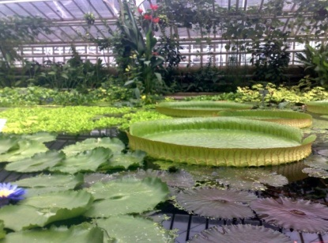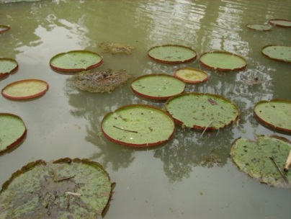

The shaman’s Tupi-Guarani t used to tell that at the beginning of the world, whenever the moon hid itself behind the horizon, looking down behind the mountains, it was going to live with its favorite maidens. They also said that if the moon fell in love with a girl, the girl would turn into a star in heaven. Naia, daughter of an Indian chief and princess of the tribe, was impressed with the story. Then at night when everyone was asleep and the moon rode the sky, she who wanted to be transformed into a star in Heaven, climbed the hills chasing for the moon in the hope that it would see her.

And so she did it every night for a long time. But the moon did not seem to notice her and could hear her sobs of sadness in the distance. One night, Naia saw in the clear waters of a lake the shape of the moon. The poor girl, imagining that the moon had come to pick her up, threw herself into the deep waters of the lake and was never seen again.

The moon, wanted to reward the sacrifice of a young beauty, and decided to turn it into a different star from those that shine in the sky. She transformed her into a "Star of the Waters," which is the Victoria Regia plant. Thus a plant was born whose white fragrant flowers only open at night, and at sunrise look rosy.

Origin: Indigenous. The largest water lily in the world is the (Nymphaeaceaea) native of the Amazon River.

