Legend of the Treasurer
In Silesia there are many mines. For ages mostly coal has been mined there, but also metal ores and salt. Miners working underground believed that they are under protection of the Treasurer. Nobody knows who he is and where he came from, but people believe that he knows all the treasures of the underworld and dangers for miners. Treasurer can help, but can also be harmful. Whom he helps? Listen.
There was a young miner working in one of mines. He had three children and a good wife. But he wasn’t happy. For a long time in places where he worked, there was very little coal, and the miners were paid for the quantity of extracted coal. The young miner was worried about the fate of his family, because his payment, although he worked hard, was not enough to buy a bread. His relatives were starving.
Once upon a time when the miner was in the place where he had to dig coal, he met an older miner. He greeted him politely. Old miner asked: “Why are you so sad?” The young miner told him his story. Then the older one, pointing with his pickaxe a place, said: “Dig here, and you will not regret.” The young miner hit in that spot and found a lot of the best quality coal. He wanted to thank for the advice, but the old miner disappeared.
After his work, young miner received a good salary. When he was coming back home happy, he was caught by an old miner. He asked: “How did it go?” Young one answered that it was very well. He also suggested the old to divide this payment for half. When he was splitting the money, one coin remained. He thought for a while and he said to the old miner: “Take it, you deserve it.” Old miner smiled and disappeared. Since that time, a young miner always earned very well and, what is most important, he avoided accidents and disasters. He never met an old miner anymore, however, he knew that he had met the Treasurer – the Guardian underground treasures, who promotes good and honest and not greedy people.

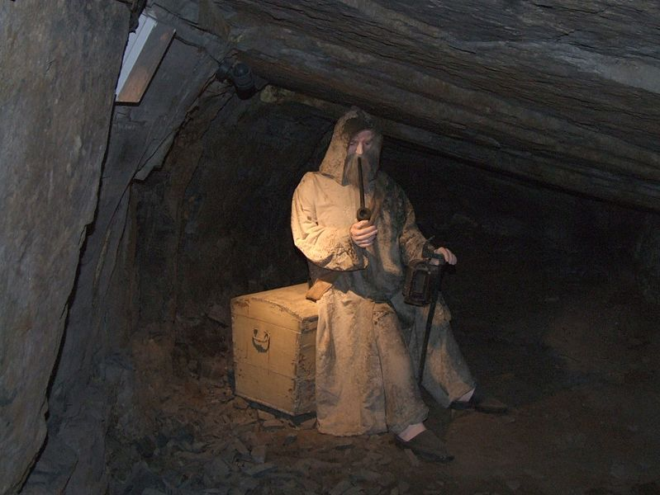
/from: www.blogi.szkolazklasa.pl/

