

Domino”: informal activity in the classroom to approach culture (warming up activity)

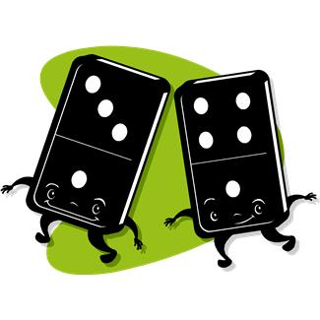

Cultural Domino about Traditions in Belgium

Suggested exercises
1. Learners watch the Power Point presentation about traditions in Belgium and/or they read the document “Traditions in Belgium”.

2. The teacher divides the class in groups of two. Each group receives a set of domino and has to put them in order.

3. In turn each student explains to his partner what he knows about the
traditions depicted on the domino cards.

- Noël
- Pâques
- Carnaval
- Saint Valentin
- Les Coteaux
- Saint Nicolas
- Saint Toré
- Le 15 août
- Le 1er mai
- La fête nationale belge

 | Saint Nicolas

Noël | 

 | 15 août

Carnaval | 

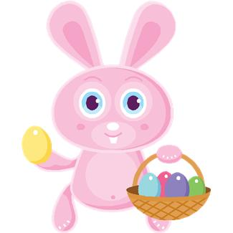 | St Toré

Pâques | 

 | Saint-Valentin

Les Coteaux | 

La Fête Nationale | 

Le 1er Mai | 

