Echternacher Sprangpressessioun (facts and legend)

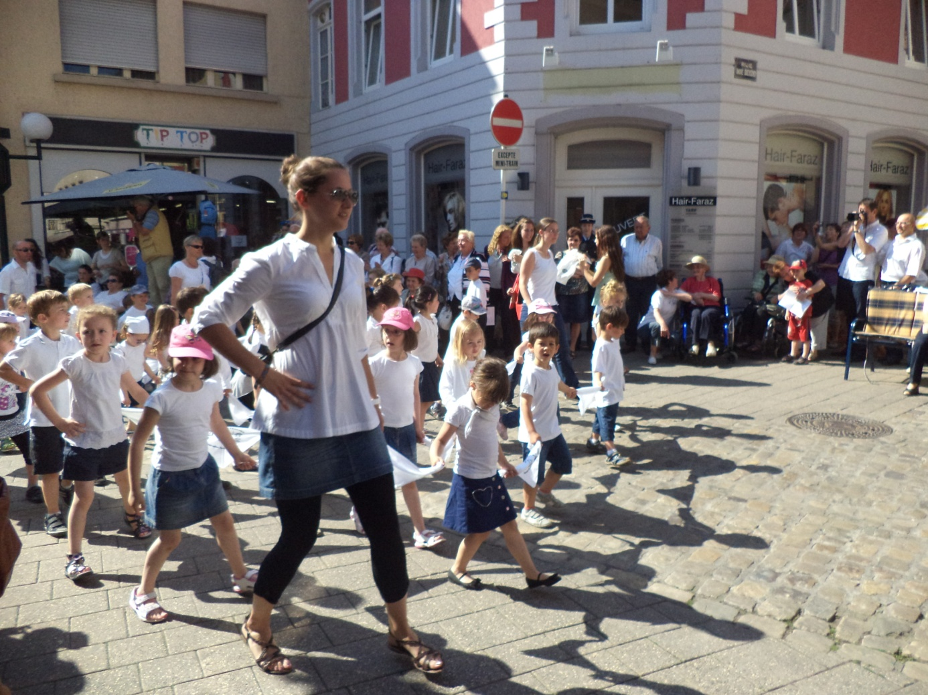

The Echternacher Sprangpressessioun is part of an old religiuos tradition.It is famous far beyond the borders of Luxembourg and has an international reputation as a very special event. It takes place on Tuesday after Whit Sunday.

The procession originated in late pagan times.

A legend of VIII century goes back to St. Willibrord , the founder of the abbey of Echternach and a man called “ Laange Veith “, known as the “ Fiddler of Echternach “.

According to the story , Veith went on pilgrimage to the Holy Land with his wife, who died during the long journey.

When Veith returned back home, his relatives were convinced that he had killed his wife . So finally Veith was sentenced by court to be hanged on the gallows .

Asked whether he had a last wish before being hanged, Veith implored the local judges to play on his fiddle one last time.

The town people who had gathered to witness his execution began to dance like mad to the fiddler`s melody and they couldn`t stop dancing even after the “innocent fiddler” had vanished from town.

St. Willibrord- who happened to be around- hurried to the market place and his prayers finally saved most people from dying of this dancing spell.

Long ago it was believed that the Sprangpressessioun would heal sick people and animals suffering from the “Vitus dance” (epilepsy) and some other aches and pains .

Nowadays the dancers of the Sprangpressession hop one step to the left and one step to the right.The procession groups are set together by rows of five to seven dancers . Each dancer - holding the ends of a handkerchief - moves forward slowly to the sounds of music similar to an old polka dance.

The procession of pilgrims- accompanied by the music bands- takes about three hours making its way through the old medieval town of Echternach and passing in front of St. Willibrord´s grave in the crypt of the Basilica.

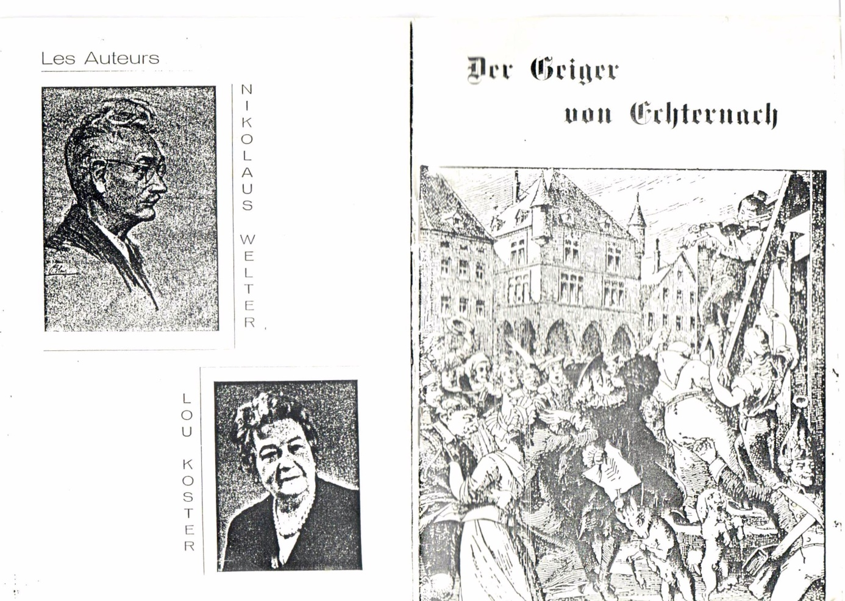

References :

- www.willibrord.lu1/Springprozession
- Lange Veith: www.gallery.gusti.lu
- Klänge zur Echternacher Springprozession (Immaterielles Kulturerbe der Menscheit UNESCO )CD-WB-052012
- Echternach en cartes postales ( Dr. Paul Spang ) Bibliothèque Européenne –Zaltbommel/Pays Bas MCMLXXXIII :ISBN 90 288 2389 1
- Anekdotische Reise durch Luxemburg ( Carlo Hemmer : Verlag der Luxemburger Jugendherbergszentrale Luxemburg .1981 Druckerei Joseph Beffort Ettelbrück )
- Der heilige Willibrord 1989 (Editions du Signe ) ISBN2-87118-015-8
- Magno Tripudio : Sur les pas de la procession dansante (FR/N/E/D/L) : DVD ( Ministère de l`Enseignement Supérieur et d e la Recherche et le Centre National de l`Audovisuel de Luxembourg)
