What traditions are bound to Carnival in Germany?

Three origins of Carnival are known:

Festivity of Spring

The first and oldest root of Carnival, also called Fasching, Fastnacht, Fasenacht, or Fasnet goes back to the Old Germans (Alte Germanen). It’s worth to mention in this connection that the word “Carnival” is coming from the Latin “carne” and “vale” what means “meat” and “good bye” (because of the following fasting time), “Fastnacht” is coming from the medieval German language “vase” what means “to make trash” (Unfug treiben).

The Old Germans believed in demons and every springtime they celebrated a gigantic festivity where the bad winter ghosts should be driven away. People were tired of the cold and frosty winter with its shortage of food and illness everywhere. So they put on horrible masks and made a fearful noise with drums, rattles and bells in the hope that the bad ghosts and demons would flee.

In later centuries the Catholic Church didn’t agree with this pagan customs and wanted to forbid them, but without any success. The people were going on with their celebrations and the only solution for the church was to make the people believe that they have to drive out the devil and not pagan demons.

Christian roots

In the 12th century the pope ordered, that between Ash Wednesday and Easter Sunday people are not allowed to drink alcohol, to eat meat, to have festivities and so on, instead of that they should pray much more. In order to be able to bear this long and hard fasting time, the days before Ash Wednesday were used by the people to celebrate excessively, to have fun and entertainment, to eat and drink a lot.

Saturnalian Festivity of Rome

The third root goes back to this festivity in the Empire of Rome. One day belongs to the servants of noble and rich people. They changed their profession and the servants were served by their masteries. They could even criticise them, make jokes about them and took the competence for one day. This was the origin of the so called “Büttenreden” in the Carnival, for example of Cologne or Mainz and the Carnival processions.

Are Carnival traditions the same in the whole country?
What is Fasching?

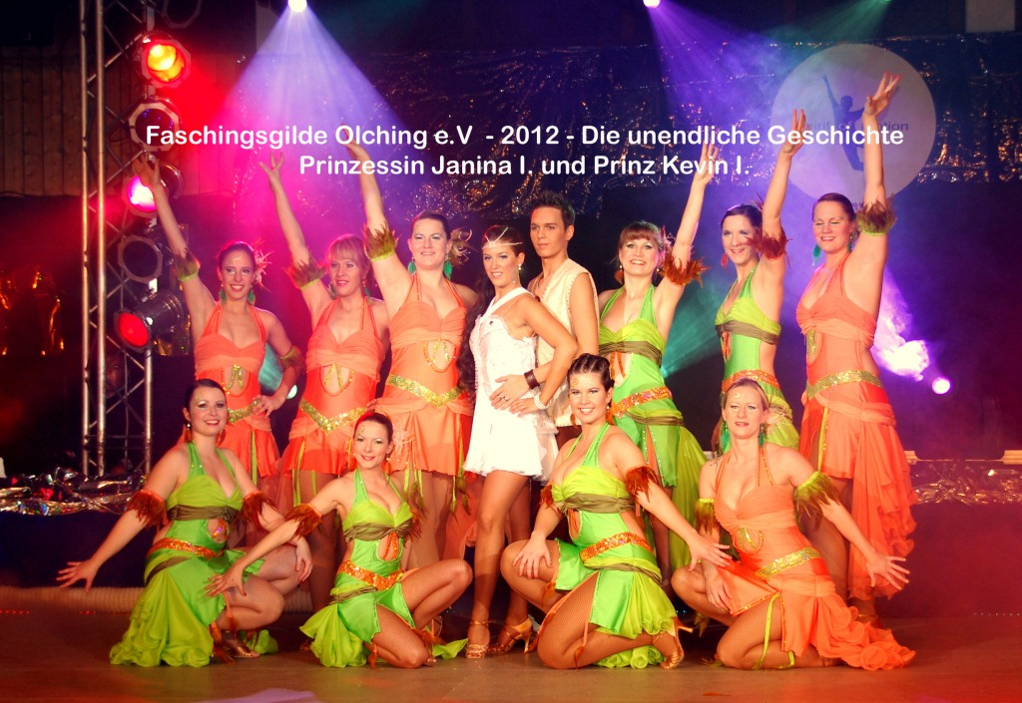
http://www.fgo.de/web/

The customs of Carnival in Germany are very different and also the name is different. In Nordrhein-Westfalen the foolish days are called “Karneval”, in Baden-Württemberg, Rheinland-Pfalz and Hessen “Fastnacht” and in Bayern, Brandenburg and Thüringen “Fasching”. Nearly everywhere the beginning of the season is the 11th of November at 11:11 am, except in the south west of Germany, where the season starts on the 6th of January.

Cologne, Düsseldorf and Mainz are very famous for their costly Carnival processions on Carnival Monday, where politicians and other well-known people are regardless criticised and mocked. Thousands of visitors are watching these events. Schools and most of the firms and shops are closed.

Funny and ironic speeches, called “Büttenreden”, are held during pompous festivities named “Prunksitzungen” that millions of people watch on TV. During these events dancing guards, called “Prinzengarden” (Prince Guard), dance in historic military costumes of 1823, the year in which the first Carnival procession in Cologne took place.

In this area it is also usual to celebrate the “Weiberfastnacht” (Women Carnival Day) on Thursday before Carnival Sunday. Men with a tie don’t wear it for a long time as it’s a great fun for women to catch them and cut their ties.

Very different from these festivities is the “Alemannische Fasnacht” or “Fasnet”, first of all celebrated in the south west of Germany, especially Baden-Württemberg. The members of the Fasnet-associations dance on the streets with awful masks and coloured clothes to the sound of a rhythmic music and they make a lot of noise with bells and rattles. The costumes and masks have a very old tradition in this region and represent devils, witches, wild people, fools and figures; they were transmitted from generation to generation. Another speciality of this area is the “Guggenmusik”, which is an unusual and false played brass-band music (e.g. http://www.youtube.com/watch?v=JYNA68CA6rk).

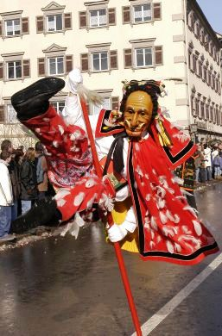

The “Narrensprung” is very famous in the town of Rottweil.

“Federahannes beim Sprung”, a picture of www.rottweil.de/tourismus

The foolish events in southern Germany, first of all in the southern part of Bavaria, are called Fasching. It’s not as spectacular as in the regions mentioned above but the Bavarians celebrate mainly the days from Thursday to Carnival Tuesday also with a lot of parties everywhere. They like to disguise themselves and many processions take place on Carnival Tuesday. They show and criticise also actual topics in a funny and ironic manner.
At the beginning of the foolish season on the 11th of November Carnival associations nominate a young pair as Carnival prince and princess. Performances with their dancing guard are very popular and the highlight of every festivity. It’s also an old tradition that Prince and Princess take over the affairs of the Lord Mayor during their reign and in a little ceremony they receive a symbolic key of the town hall.

These are only a few examples for Carnival activities in Germany. There are a lot of events in other parts of the country with special traditions and celebrations.

But one thing is the same everywhere – on Ash Wednesday everything is over!

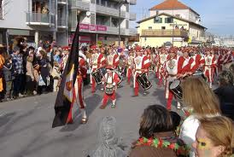
Carnival Procession in Olching

Links:

http://www.youtube.com/watch?v=4jbOSjMDBQo&feature=relmfu („Schäfflertanz und Weiberfasching“ at the Viktualienmarkt in Munich/Bavaria)

