

“Taboo”: informal activity in the classroom to approach culture (warming up activity)

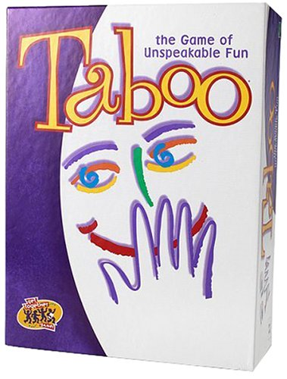

Step 1: The idea is to apply the rules of the game “TABOO” but in a version based on culture and its representations.

Step 2: We choose a group of terms that should be guessed by the classroom or by groups of 3 people. For example:
To GUESS:
CHRISTMAS

FORBIDDEN WORDS:
- Red
- 25th december
- Christmas Tree
- Santa Klaus
- Celebration
- …
To GUESS:
CARNIVAL

FORBIDDEN WORDS:
- costume
- mask
- Halloween
- Rio de Janeiro
- Celebration
- Venice
- …

To GUESS:
EASTER

FORBIDDEN WORDS:
- egg
- bell
- bunny
- chocolate
- Spring
- Celebration
- …

We can also prepare some cards about more specific terms relative to those celebrations. For example:

To GUESS:
GIFT

FORBIDDEN WORDS:
- to offer
- a present
- an occasion
- Celebration
- …

To GUESS:
FANCY DRESS
Or COSTUME

FORBIDDEN WORDS:
- Halloween
- cloth
- Carnival
- To disguise
- …

Step 2 BIS: It’s also possible to split the classroom into groups of 3 people and ask to the groups to create cards for each thema (Carnival, Christmas, Easter…).

Material request

1. cards to guess
2. a chronometer

