

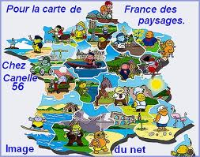

FRENCH FESTIVITIES
I’ve prepared the following activity after having worked different texts talking about different holidays all around France and adapted from the text book we worked with.
The steps are the following:
Step 1: Students, in groups of 3, were given, on the one hand, a calendar (without any date) on a sheet of paper that they had to fill in. On the other hand, they received different small “flashcards” on which there were written different dates, expressions and also there were flashcards where they could see some images. Students had to fill in the grid with these small “flashcards”. How?
Step 2: Some of the students knew already some of the French holidays, so, they could complete part of the table. For the rest of the information, students looked in Internet (we went to the computer lab) for this information in order to complete the rest of the grid in distribute correctly the “flashcards”
Step 3: Once the information was found and distributed on the grid, students had to explain orally what they had found to the class and other students could complete with different information.
Step 4: Finally, students had to compare this calendar with the Spanish one.
DOCUMENT 1
FÊTES | CE QU’ON PEUT VOIR OU FAIRE | CE QU’ON OFFRE OU ENVOIE | CE QU’ON MANGE | CE QU’ON DIT
DOCUMENT 2
JOUR DE L’AN | ÉPIPHANIE | SAINT-VALENTIN | MARDI GRAS | PRINTEMPS DES POÈTES (À BOURGES)
PÂQUES | POISSON D’AVRIL | FÊTE DU TRAVAIL | FÊTE NATIONALE | HALLOWEEN
TOUSSAINT | SAINT-NICOLAS (dans l’Est) | NOËL | SAINT-SYLVESTRE | BONNE ANNÉE !
J’AI LA FÈVE. JE SUIS LE ROI/LA REINE ! | JE T’AIME ! | POISSON D’AVRIL ! | JOYEUX NOËL ! | BONNE ANNÉE !
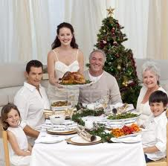 | 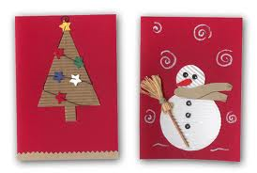 | 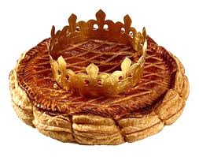 |  | 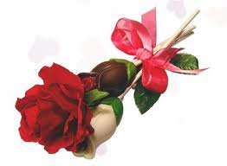
 | 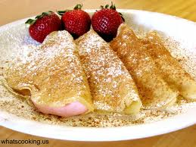 | 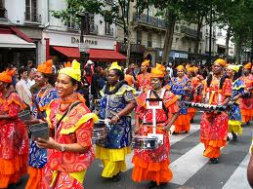 | 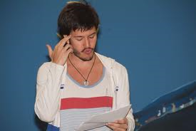 | 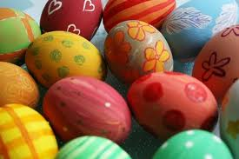
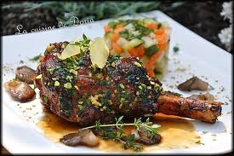 | 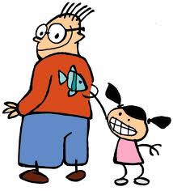 | 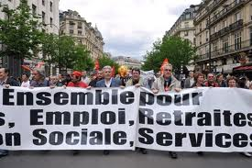 | 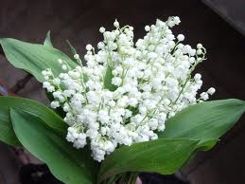 | 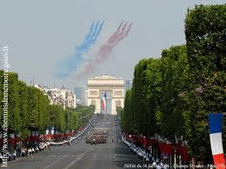
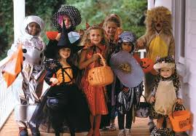 | 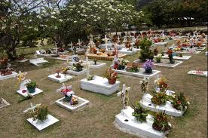 | 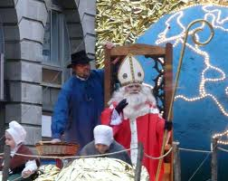 | 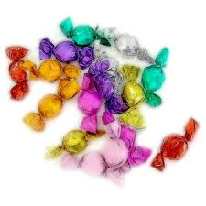 | 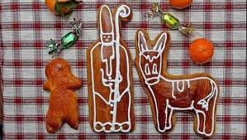
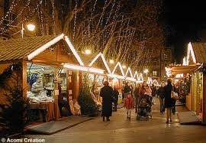 | 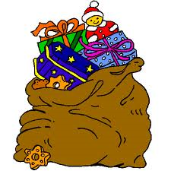 | 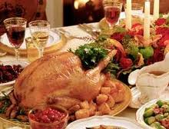 |  | 