“Folk festivals in Bavaria”
Informal Activity in the Classroom to Approach Culture
(Intercultural activity)

Suggested exercises
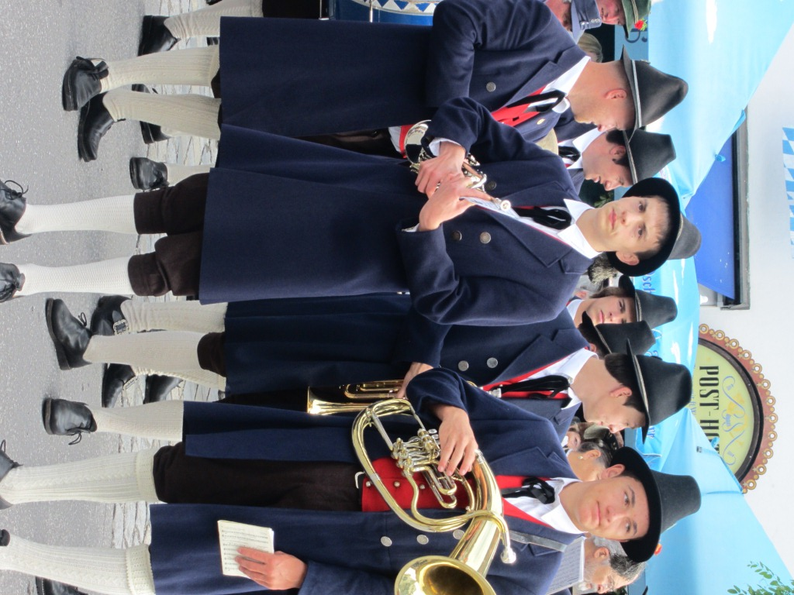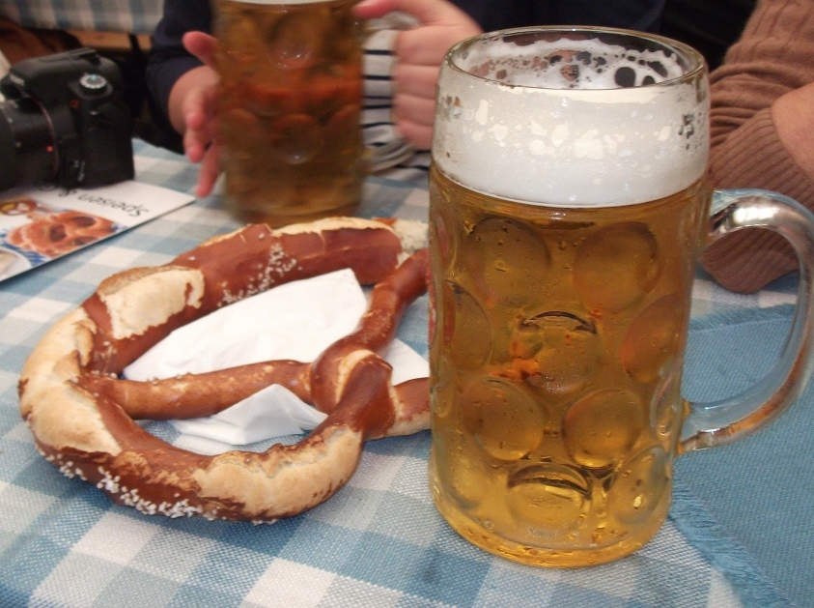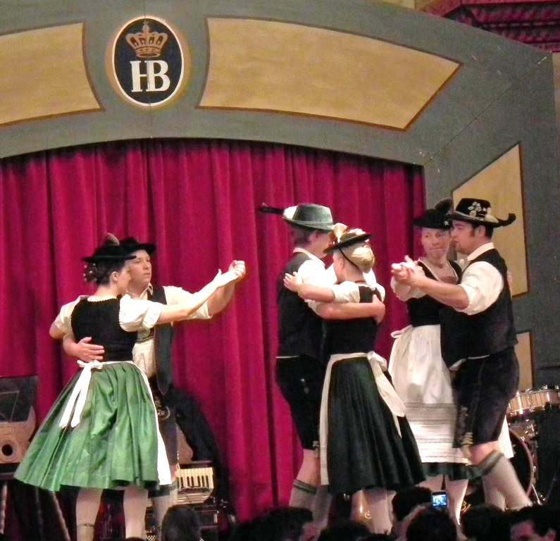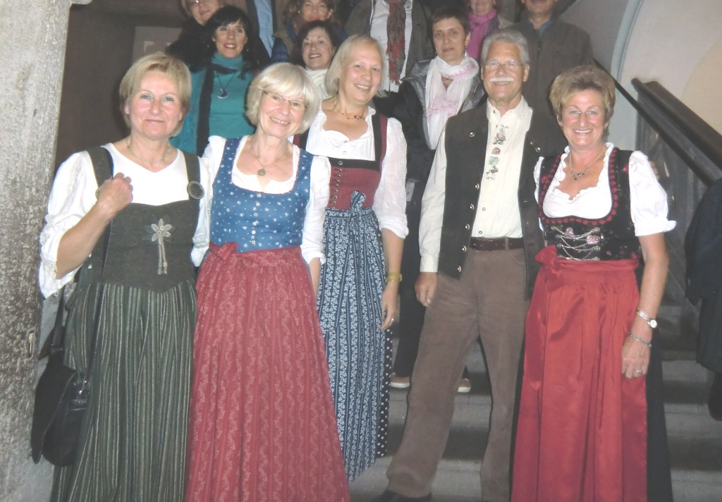
Step 1: warm up
- Look at the pictures. What do you think they refer to?
- Can you guess in which country they were taken?
- Do you see any similarity with festivals in your country?
- At what time of the year do festivals usually take place? In your country? Abroad?

Step 2: Traditional clothes

- Are such traditional clothes familiar to you?
- Do you know if people wear such clothes in everyday life? In Germany? In your country?
- Do you see any similarity in these traditional clothes and those of your country?
- Do men also wear a hat while dancing in your country?

Step 3: Food and drinks

- Which traditional food and drinks are offered in such occasions?
- In which premises do festivals take place in your country? Compare with premises in other countries.
- Are food and drinks expensive at festivals?
- What kind of sweet are sold at festivals?

Step 4: Cross culture video: http://www.youtube.com/watch?v=ln3AgZ5oCDo

- Compare what you see in the video and on the pictures above.

