Discovering European Cities: Munich / Germany
Informal Activity in the Classroom to Approach Culture
(Activity with Video Clip)

Suggested exercises
Step 1:
- Learners watch the clip about Munich twice.
- After that they answer the following list of questions

From what is Munich the Capital?
- How old is Munich?
- Where is the heart of Munich located?
- What took place on “Marienplatz” in former times?
- Where is the Tourist Information?
- Is there any castle in Munich?
- Do you know Munich “Oktoberfest”?
- Are there parks and gardens?
- What used Munich to be called?
- Where can you get a city map?
- Did you see musicians in the video?
- Is Munich a business city?
- Who lived in the castle of “Nymphenburg”?
- Is Munich the largest city of Germany?

Step 2: Pair work

- Learners watch the clip again and check their answers in pair.

Step 3: Match the pictures

- A range of pictures about Munich are pinned on a board. Some are not related to the video.
- Learners have to decide if something is mentioned about each picture in the clip or not.
- They check their answer altogether.

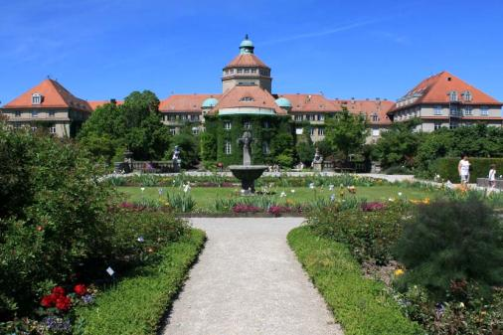  Botanic Garden | 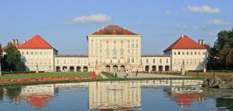  Castle of Nymphenburg
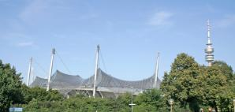  Olympic Parc | 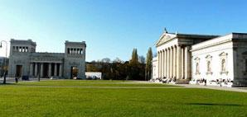  Museums
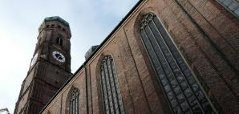  Cathedral: Frauenkirche | 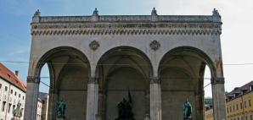  Odeon Square
  Zoo | 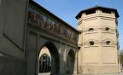  Isartor
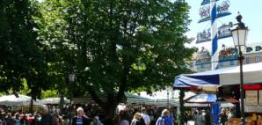  Viktualienmarkt | 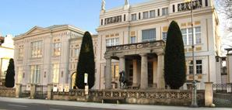  Villa Stuck
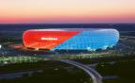  Allianz Arena | 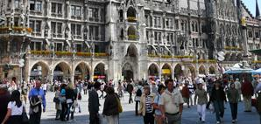 Marienplatz
Pictures from: http://www.muenchen.de/sehenswuerdigkeiten

Link to the clip: http://www.youtube.com/watch?v=tkU0FUSDfE0

