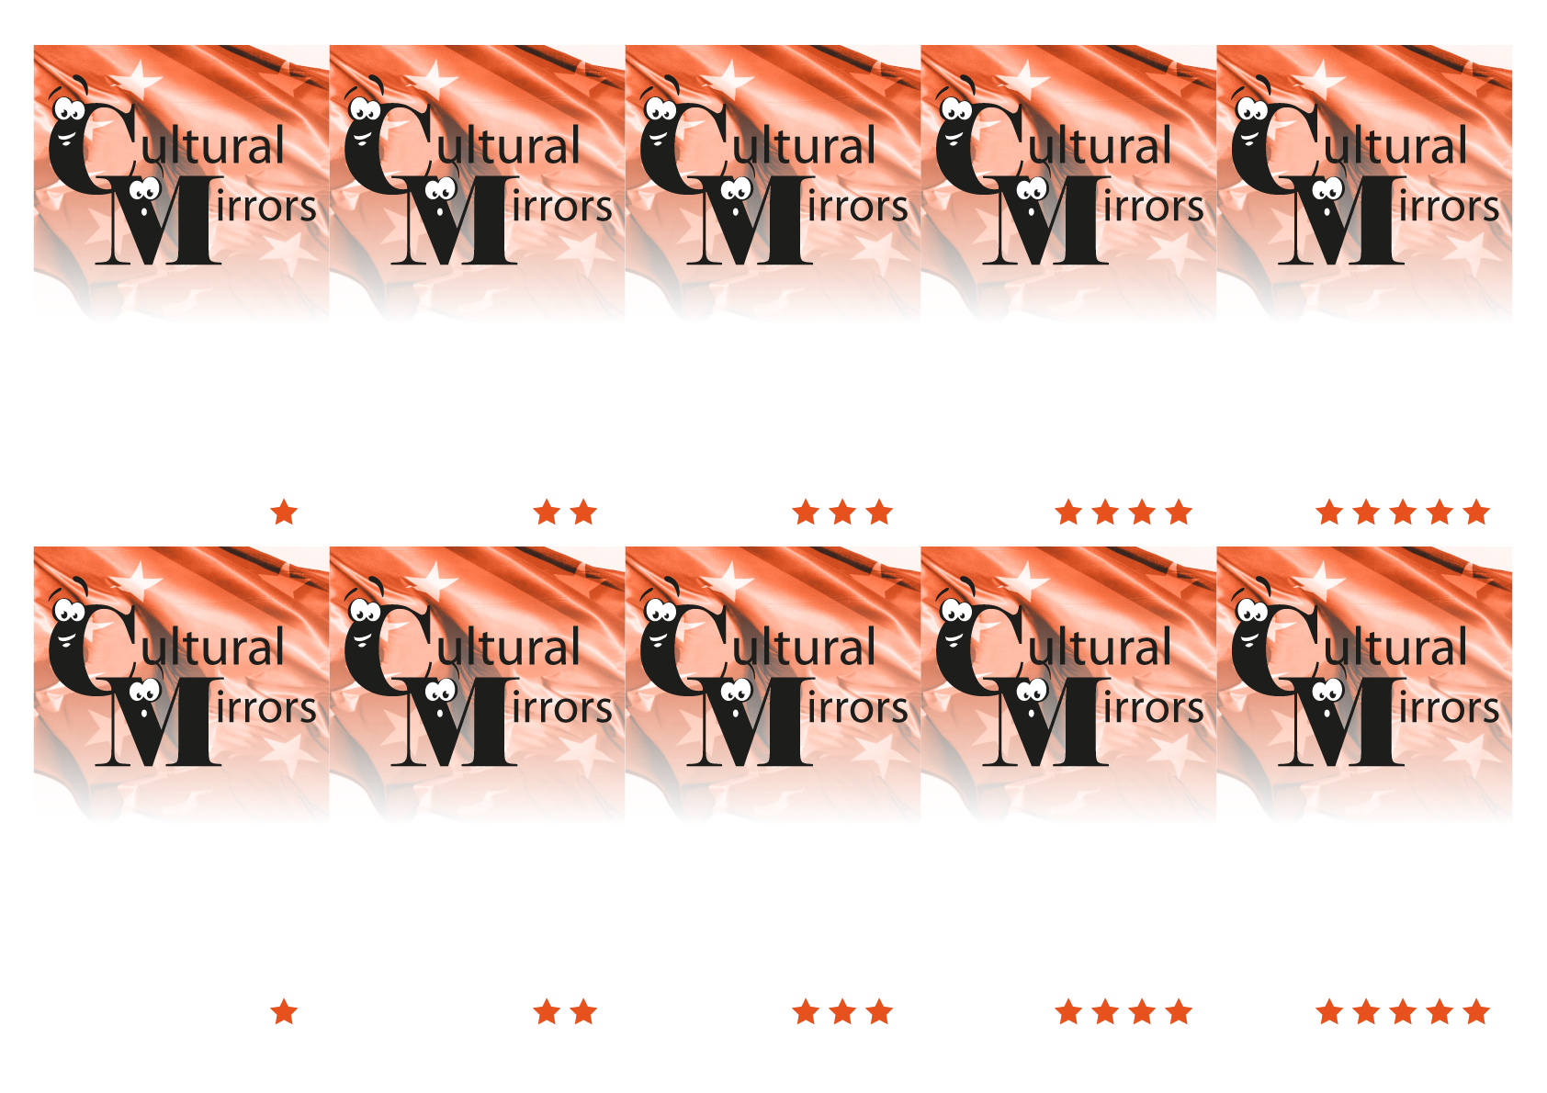
2. Apple

2. Lenin

2. The East
2. Raclette
2. In 1847

1. Italian

1. Bern
1. Basel.
1. Felix and Regula

1. Napoléon III

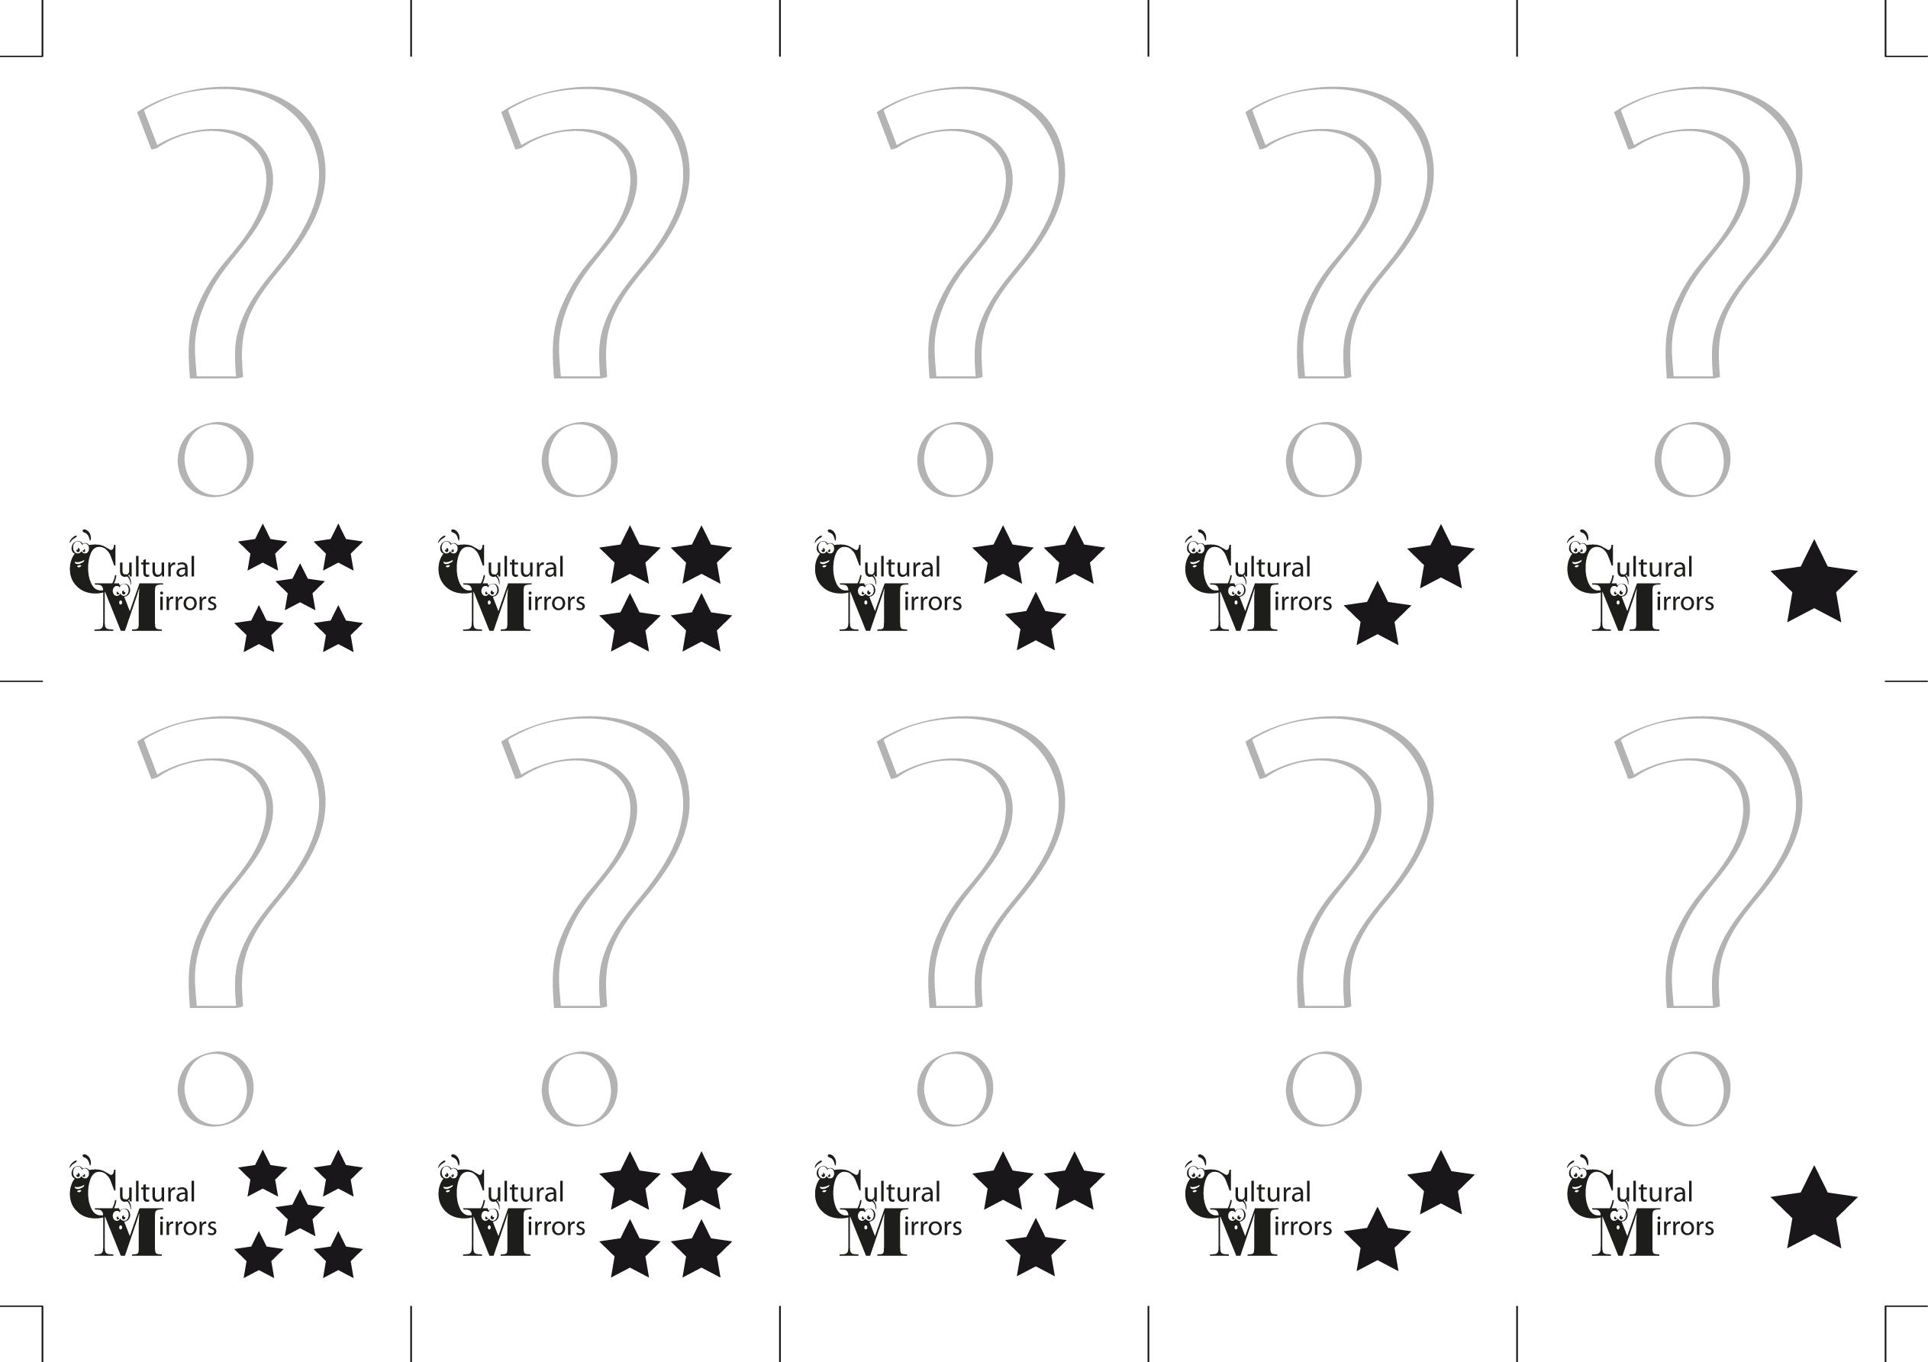
1. Which French politician possessed the Swiss citizenship?

1. What are the names of the patron saints of Zürich ?

1. Which Swiss city is only 15 minutes away from both France and Germany ?
…
1. Which of the following Swiss cities does not have a lake: Bern, Lucern, Biel, Geneva

1. What language is spoken in the south of Switzerland?

2. When did the Swiss fight the last war in their history?
2. What is the name of the typical Swiss dish made of melted cheese and potatoes ?

2. Which part of Switzerland is the home of the famous novel character Heidi?
2. Which of these lived in Switzerland before becoming famous: Lady Gaga, Lenin, Sarkozy, Picasso

2. What fruit did William Tell shoot at?

