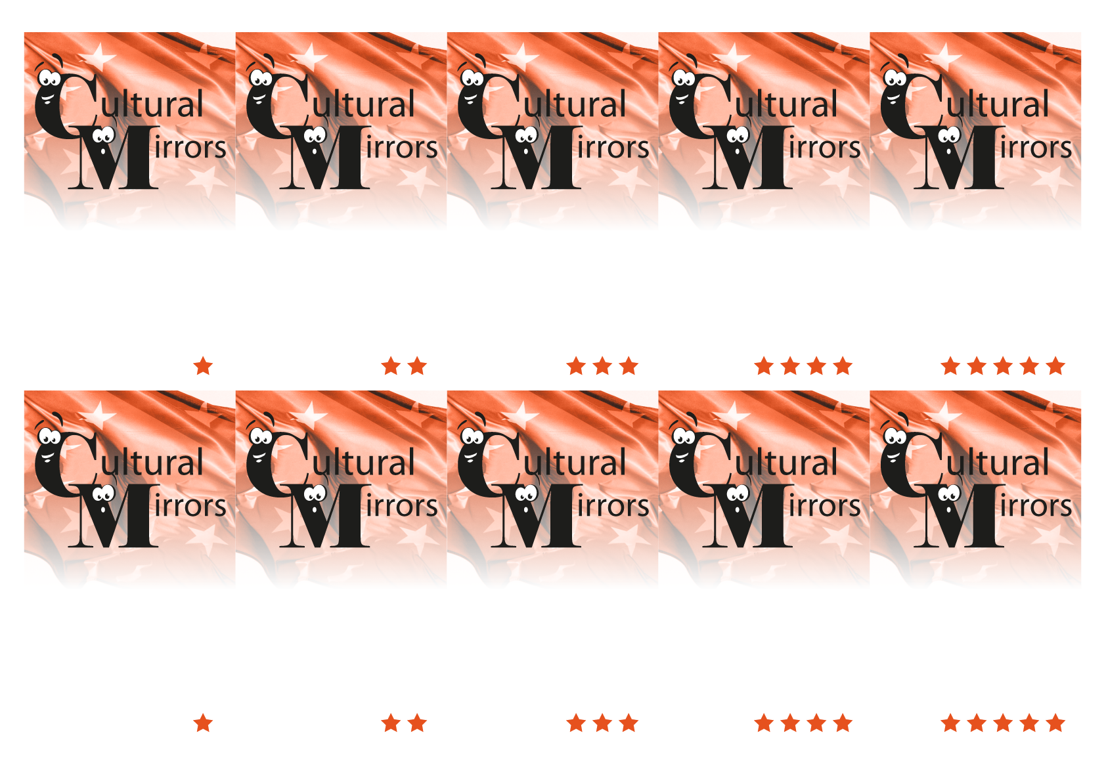
4. Roman Catholic
4. Swiss Confederation
4. It is a traditional Swiss dish containing melted cheese in a pot and eaten together with pieces of bread on long forks
4. United Nations

4. The Federal Charter was established between the three founding cantons Uri, Schwyz und Unterwalden

3. Seven

3. German, French, Italian and Romansh

3. “Grüezi”
3. They ignite fireworks to celebrate their National Holiday.
3. Around 100

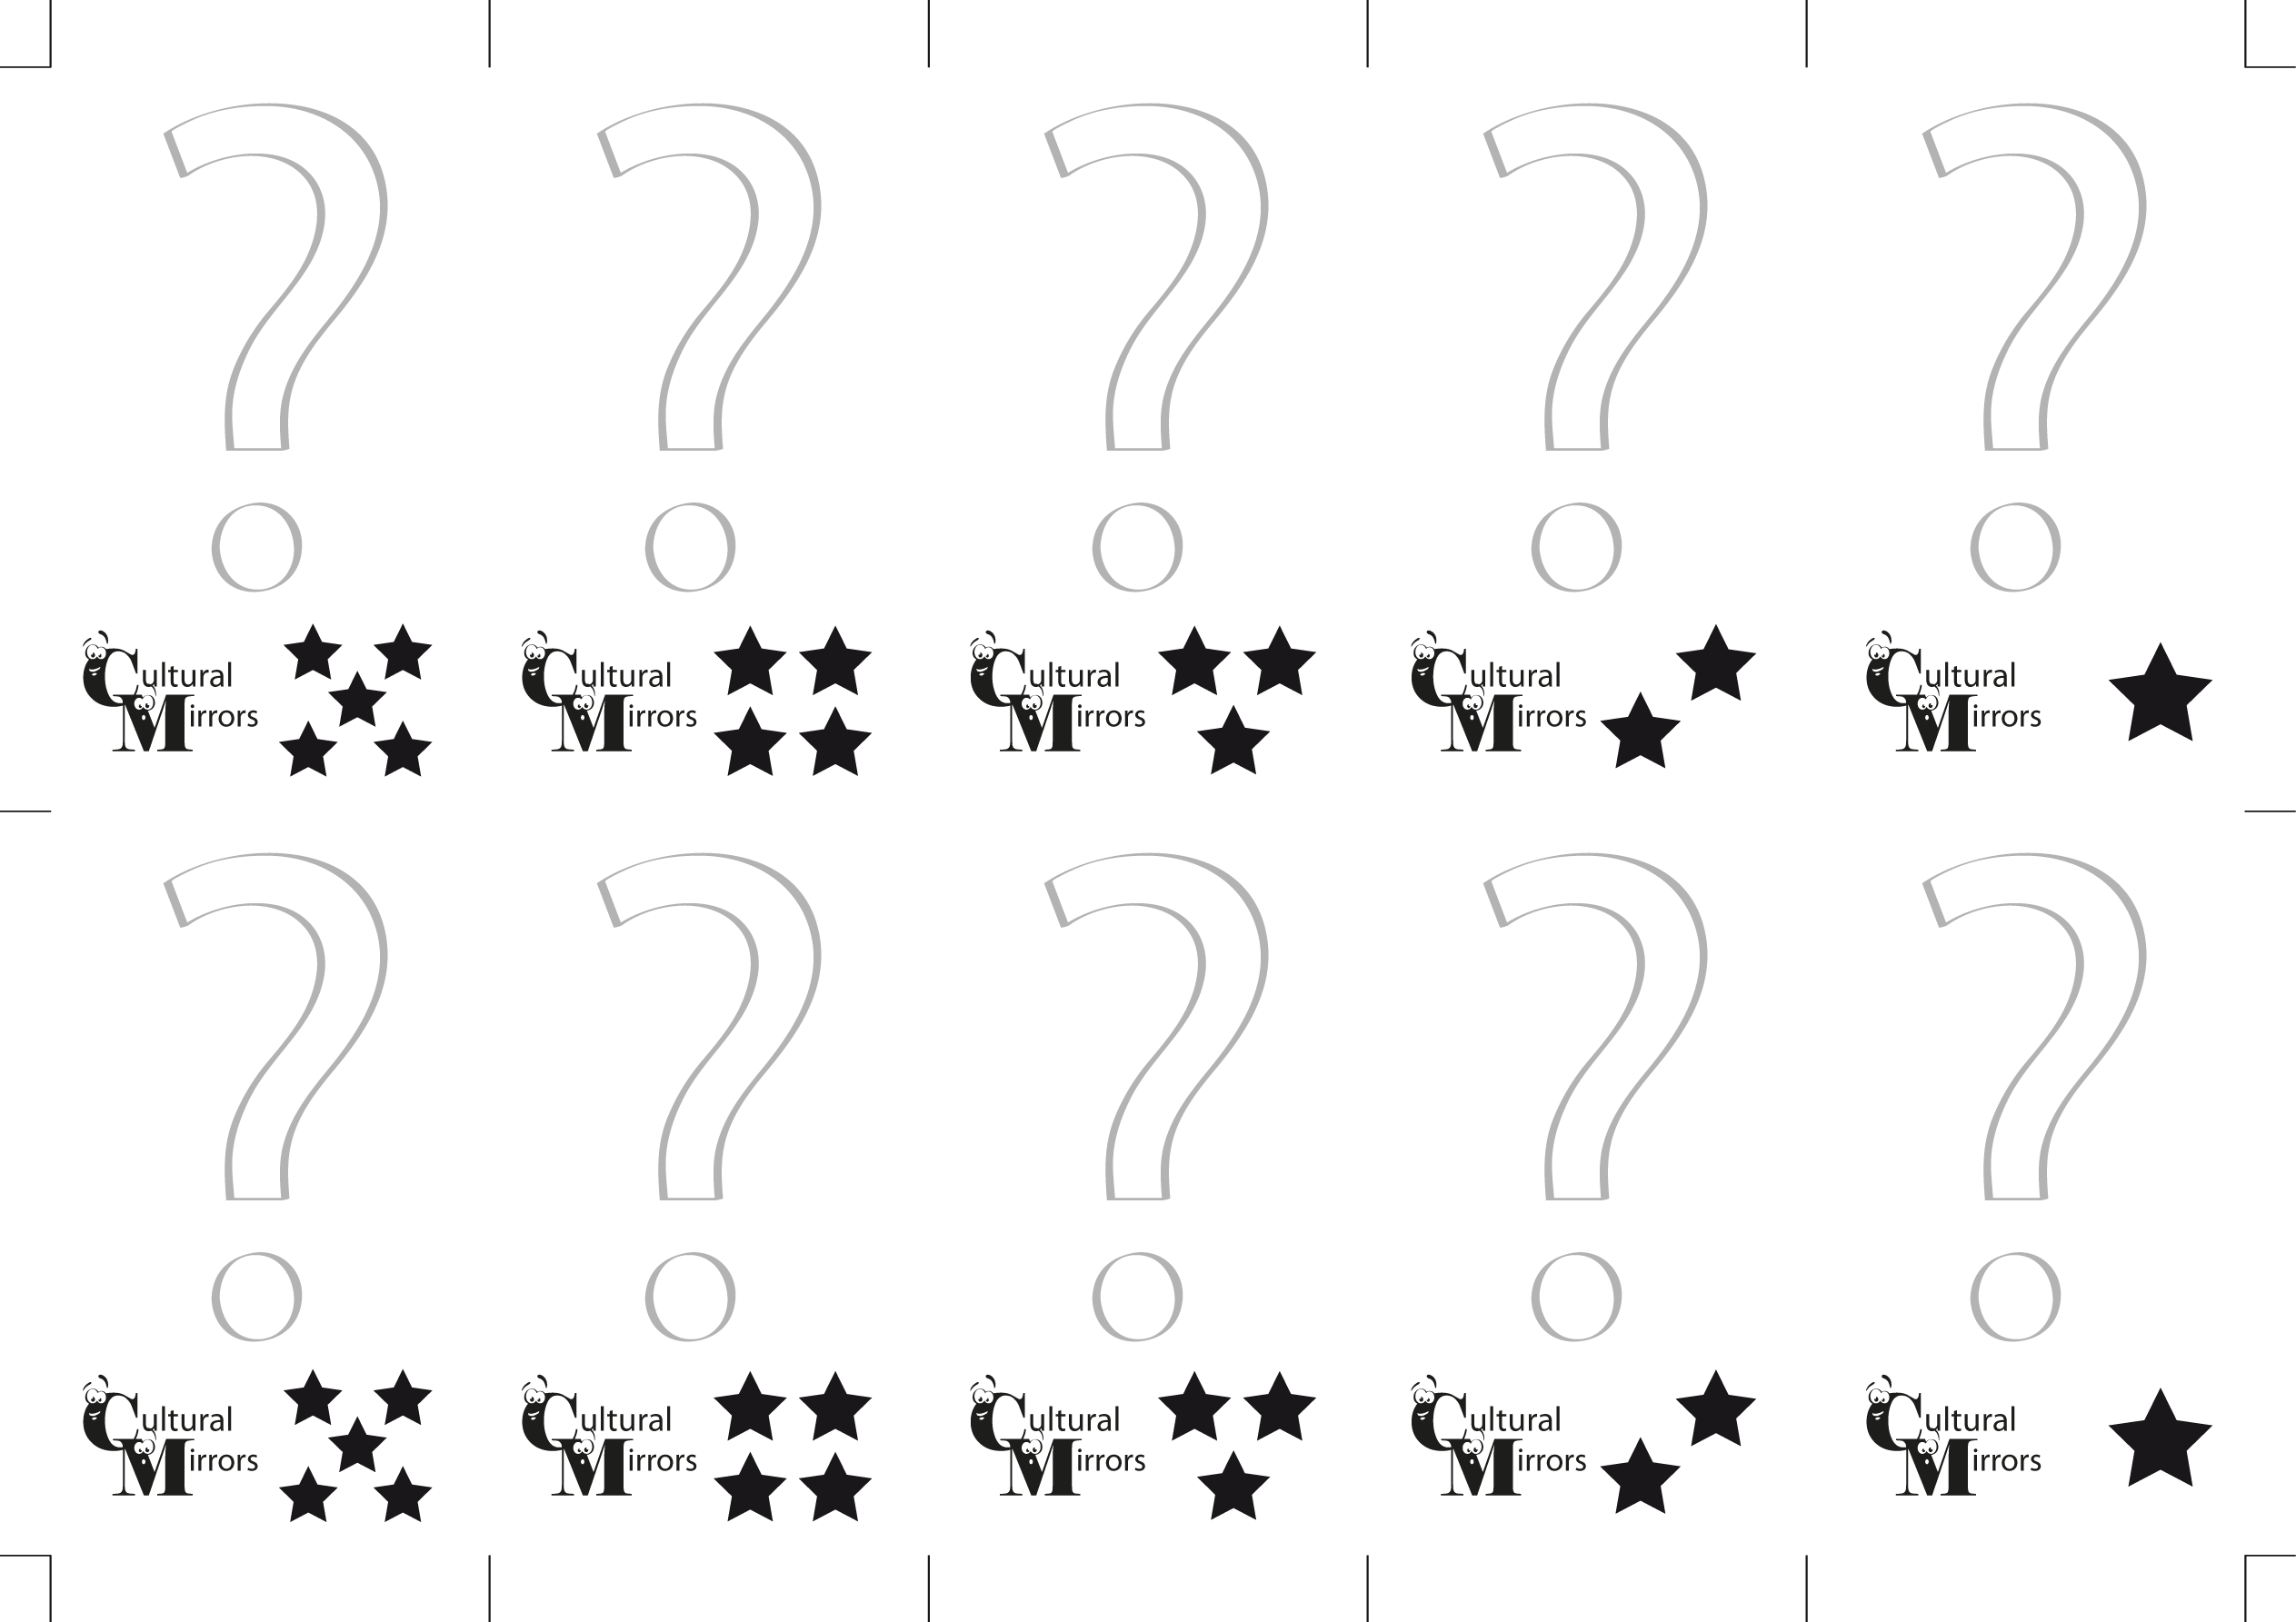
3. How many Swiss mountains are higher than 4000 m ?

3. What do the Swiss do on August 1^{st?}

3. What do the Swiss say when they greet someone in a formal way?
3. What are the official languages in Switzerland ?
3. How many members the Swiss Government consists of?

4. What international organization did Switzerland become a member of in 2002?

4. What is “Fondue”

4. What is the official name of the Swiss state ?

4. Which is the biggest religion in Switzerland ?

4. Why is the year 1291 important for in Swiss history?

